Integration of Taglish Speech-to-Text and an Applied Legal Consequence Game to an NLP-Based Chatbot Support System for Children in Conflict with the Law

A Thesis Presented to the

Faculty of Information Technology Department

College of Information System and Technology Management

Pamantasan ng Lungsod ng Maynila

In Partial Fulfillment of the Requirements for the Degree

Bachelor of Science in Information Technology
__________________________________

By

Cedrix Camasis Capco Jr.

Jamie Cunanan Jarlego

Thesis Adviser

Prof. Ariel Antwaun Rolando C. Sison

September 2026

APPROVAL SHEET

The thesis hereto titled

INTEGRATION OF TAGLISH SPEECH-TO-TEXT AND AN APPLIED LEGAL CONSEQUENCE GAME TO AN NLP-BASED CHATBOT SUPPORT SYSTEM FOR CHILDREN IN CONFLICT WITH THE LAW
prepared and submitted by Cedrix C. Capco Jr. and Jamie C. Jarlego in partial fulfilment of the requirements for the degree of Bachelor of Science in Information Technology has been examined and is recommended for acceptance and approval for Oral Examination.

_____________________

Prof. Ariel Antwaun Rolando C. Sison
Adviser

PANEL OF EXAMINERS

Approved by the Committee on Oral Examination
with a grade of _________ on _______.

_______________________
Panel Chair
Chairman

_______________________ _______________________
Prof. Vivien A. Agustin Prof. Mark Anthony Mercado
Panel Member Panel Member

Accepted and approved in partial fulfilment of the requirements for the degree of Bachelor of Science in Information Technology.

_______________________ _______________________
Name Dr. Khatalyn E. Mata
Director / Chairman Dean
Graduate Program College of Information Systems and
IT Department Technology Management
ABSTRACT

The maximum length of the abstract is one to two pages. Use 12-point Times New Roman and 1.5-line space.
An abstract should contain the summary of the study including significant findings, information, data and analysis. Also, problems and objectives are solved and addressed.

ACKNOWLEDGEMENTS

The acknowledgements should also be limited to one page but can be exceeded if necessary.
The CISTM-Graduate Program would like to thank Ms. Diana Jane Saya for helping us format this thesis manuscript for the undergraduate and graduate program of the College of Information Systems and Technology Management.

TABLE OF CONTENTS
APPROVAL SHEET i
ABSTRACT ii
ACKNOWLEDGEMENTS iii
TABLE OF CONTENTS v
LIST OF FIGURES vi
LIST OF TABLES vii
INTRODUCTION 1
1.1 Background 1
1.2 Fonts 1
1.3 Paragraphs and Line Spacing 2
1.3.1 Section numbering 2
1.3.2 Lists 2
1.4 Significance of the Study 2
1.5 Scope and Limitations 2
REVIEW OF RELATED LITERATURE 3
2.1 Referencing within the Text 3
THEORETICAL FRAMEWORK 3
3.1 Equations 3
MATERIALS AND METHODOLOGY 4
4.1 SI Units 4
4.2 Figures 4
RESULTS AND DISCUSSION 6
5.1. Tables 6
CONCLUSIONS AND RECOMMENDATIONS 7
LIST OF REFERENCES 8
APPENDIX A: GANTT CHART 9
APPENDIX B: MATERIAL SAFETY DATA SHEETS (MSDS) 10
A.1 Requirements for MSDS 10

LIST OF FIGURES

Figure No. | Figure Title | Page
Figure 2.1 | Conceptual Framework of the Study (Input-Process-Output Model) | 25
Figure 3.1 | Agile Methodology of the Study | 29
Figure 3.2 | System Architecture | 35
Figure 3.3 | System Flowchart | 38
Figure 3.4 | Module 1 Flowchart: Taglish Speech-to-Text | 42
Figure 3.5 | Module 2 Flowchart: NLP Intent Recognition and Reply | 44
Figure 3.6 | Module 3 Flowchart: Applied Legal Consequence Game | 46
Figure 3.7 | Use Case Diagram | 47
Figure 3.8 | Level 0 Context Diagram | 49
Figure 3.9 | Level 1 Data Flow Diagram: SOP 1, Taglish Speech-to-Text | 52
Figure 3.10 | Level 1 Data Flow Diagram: SOP 2, Enhanced NLP Intent Recognition | 54
Figure 3.11 | Level 1 Data Flow Diagram: SOP 3, Applied Legal Consequence Game | 57
Figure 3.12 | Level 1 Data Flow Diagram: SOP 4, System Performance Evaluation | 58
Figure 3.13 | Level 1 Data Flow Diagram: SOP 5, Usability and Acceptability Evaluation | 60
Figure 3.14 | Content Data Model of the Case File | 62

LIST OF TABLES

Table No. | Table Name | Page
Table 3.1 | Sprint Schedule of the Study | 30
Table 4.1 | Profile of Respondents | 72
Table 4.2 | Word Error Rate Results | 73
Table 4.3 | Intent Classification Accuracy Results | 75
Table 4.4 | Intent Classification Accuracy per Intent | 75
Table 4.5 | Mean SUS Score per Respondent Group | 76
Table 4.6 | SUS Score Range and Adjective Rating | 76
Table 4.7 | Summary of Open-Ended Responses | 77

Chapter One
INTRODUCTION

  - Background of the Study

Children in Conflict with the Law (CICL) occupy one of the most vulnerable positions within the Philippine justice system. Under Republic Act No. 9344, the Juvenile Justice and Welfare Act of 2006, as amended by Republic Act No. 10630, a CICL is defined as a child who is alleged as, accused of, or adjudged as having committed an offense under Philippine laws (Republic Act No. 9344, 2006). The law departs from a punitive framework and instead institutionalizes restorative justice, prioritizing diversion, intervention, rehabilitation, and reintegration over prosecution and detention (Juvenile Justice and Welfare Council, n.d.). Despite this progressive legal architecture, the implementation gap remains wide. Many children who enter the system possess little to no understanding of their rights, the diversion process, or the legal consequences of their actions, and the social workers, barangay officials, and counselors tasked with guiding them are chronically under-resourced. Traditional counseling and intervention methods often face limitations in reaching and engaging young individuals, a constraint that has motivated the exploration of technology-mediated support channels (Romilla et al., 2023).

One of the most direct responses to this gap emerged from Pamantasan ng Lungsod ng Maynila, where Romilla et al. (2023) developed a chatbot support system for children in conflict using natural language processing (NLP) techniques. Their system targeted delinquent behaviors, specifically juvenile smoking and drinking, by analyzing and interpreting the language used by young users and providing tailored responses and guidance drawn from a curated knowledge base. The development process involved data collection from juveniles in conflict, knowledge base construction, chatbot model training, and validation through user feedback, with preliminary results indicating promising outcomes in engagement, acceptance, and efficacy (Romilla et al., 2023). The study established that conversational agents can serve as an accessible and personalized support channel for a population that is frequently hesitant to seek help through formal, adult-mediated avenues.

However, the same study explicitly acknowledged that further research and refinement are necessary to enhance the system's accuracy, adaptability, and overall impact in real-world scenarios (Romilla et al., 2023). Two limitations are particularly consequential when the system is examined against the realities of its intended users. First, the system accepts input exclusively through typed text and processes it against a knowledge base oriented toward relatively well-formed input. This design assumption conflicts with the actual linguistic behavior of Filipino youth, who overwhelmingly communicate in Taglish, the fluid, intra-sentential code-switching between Tagalog and English that has been described as the de facto lingua franca of the Philippines (Montalan et al., 2025). Computational systems have historically treated code-switched input as noise rather than as a structured bilingual phenomenon, degrading performance in downstream conversational tasks. Moreover, text-only interaction presupposes typing fluency and literacy levels that cannot be assumed among CICL, many of whom have interrupted schooling. Advances in automatic speech recognition (ASR), particularly large-scale weakly supervised models such as Whisper, which was trained on 680,000 hours of multilingual audio (Radford et al., 2023), and fine-tuning approaches that have dramatically reduced word error rates for low-resource Southeast Asian languages (Pong et al., 2025), make a Taglish speech-to-text (STT) front end technically feasible. Local research has likewise demonstrated that transformer-based acoustic models can be adapted to Filipino speech, including the distinct acoustic properties of children's voices (Santiago et al., 2025).

Second, the foundational system delivers guidance purely through conversational exchange, which places the full burden of engagement on dialogue alone. Research on game-based learning consistently shows that educational gamification has a potential positive impact on the academic performance, commitment, and motivation of students (Manzano-Leon et al., 2021), and game-based approaches have been successfully applied to legal education specifically, where structured play helps learners internalize legal reasoning and consequence (Yuratich, 2021). For CICL, whose engagement with abstract legal text is minimal, an applied legal consequence game, composed of storyboard-based scenario modules in which the player examines a child's account of a depicted offense against the evidence and then observes the corresponding legal outcomes under RA 9344, offers a concrete, experiential complement to chatbot dialogue. Parallel developments in legal technology reinforce this direction: AI-powered chatbots are increasingly positioned as instruments for widening access to justice among populations that cannot afford or access formal legal assistance (Ajmi, 2024; Chien & Kim, 2024), yet these tools remain overwhelmingly English-centric and text-based, leaving linguistically marginalized users underserved (Tan et al., 2023).

This study therefore proposes an enhancement of the NLP-based chatbot support system of Romilla et al. (2023) through two integrations: a Taglish speech-to-text module that allows CICL to speak naturally in code-switched Filipino-English, and an applied legal consequence game that translates the provisions of RA 9344 into interactive, choice-driven scenarios. The enhancement directly addresses the accuracy, adaptability, and engagement refinements called for by the foundational study, and situates the system more firmly within the linguistic and educational realities of its intended users.

  - Statement of the Problem

The existing NLP-based chatbot support system for children in conflict with the law developed by Romilla et al. (2023) demonstrated the viability of conversational agents as an intervention channel, but its design imposes two barriers to real-world impact. First, its text-only, well-formed-input orientation is misaligned with the natural communication of Filipino youth, who speak in Taglish and who may lack the typing fluency or literacy required for sustained text interaction, creating a language and modality barrier at the first point of contact. Second, its reliance on dialogue as the sole delivery mechanism constrains engagement, since abstract conversational advice does not let CICL experience the consequences of legal choices, a limitation reflected in the foundational study's own call for improved accuracy, adaptability, and impact. An enhancement integrating Taglish speech input and an applied legal consequence game is therefore warranted.

Specifically, this study seeks to answer the following questions:

    - How may a Taglish speech-to-text module be developed and integrated into the existing chatbot to accurately transcribe code-switched Filipino-English speech?

    - How may the chatbot's NLP intent recognition be enhanced to correctly interpret transcribed Taglish input?

    - How may an applied legal consequence game, composed of storyboards depicting offenses commonly committed by CICL, be designed and integrated to teach the legal consequences of their actions under Republic Act No. 9344?

    - What is the level of performance of the enhanced system in terms of Word Error Rate (WER) of the Taglish speech-to-text module and intent classification accuracy of the enhanced NLP module?

    - What is the level of usability and acceptability of the enhanced system as evaluated by the intended users and IT experts using the System Usability Scale (SUS)?

  - Objective of the Study
    - General Objective

This study aims to enhance the NLP-based chatbot support system for children in conflict with the law developed by Romilla et al. (2023) by integrating a Taglish speech-to-text module and an applied legal consequence game, thereby removing the language and modality barriers of the existing system and improving user engagement and legal awareness.

    - Specific Objectives

In accordance with the research questions formulated in Section 1.2, this study specifically aims:

- Taglish Speech-to-Text Module. To develop and integrate a Taglish speech-to-text module that accurately transcribes code-switched Filipino-English speech.

- Enhanced Intent Recognition. To enhance the chatbot's NLP intent recognition to correctly interpret transcribed Taglish input.

- Applied Legal Consequence Game. To design and integrate an applied legal consequence game, composed of at least ten storyboards depicting offenses commonly committed by CICL, that teaches the legal consequences of their actions under Republic Act No. 9344.

- Performance Evaluation. To evaluate the performance of the enhanced system in terms of Word Error Rate and intent classification accuracy.

- Usability Evaluation. To evaluate the usability and acceptability of the enhanced system among intended users and IT experts using the System Usability Scale.

  - Significance of the Study

The results of this study will be beneficial to the following:

Children in Conflict with the Law. As primary beneficiaries, CICL gain a support channel that accepts their natural spoken language and removes literacy and typing barriers, while the legal consequence game lets them understand their rights and the outcomes of their choices under RA 9344 in concrete terms. Accessible legal technology has been shown to help underserved individuals navigate legal issues they would otherwise face alone (Ajmi, 2024).

Social Workers, Counselors, and Barangay Officials. Frontline implementers of diversion and intervention programs gain a supplementary tool for counseling and legal orientation that extends their limited capacity.

Legal Institutions and the JJWC. The study contributes a local model of how restorative justice principles can be operationalized through technology, supporting the JJWC mandate to implement intervention programs (Juvenile Justice and Welfare Council, n.d.). Field studies have shown that generative AI can measurably extend the reach of legal aid organizations (Chien & Kim, 2024).

Developers and Researchers. The study provides empirical evidence on Taglish speech recognition performance and on integrating game-based learning into conversational systems, contributing to the limited literature on code-switched Filipino NLP and legal serious games.

Future Researchers. The study serves as a reference for enhancement studies involving code-switched speech interfaces, gamified legal education, and support systems for vulnerable populations.

  - Scope and Limitations

This study covers the enhancement of the existing NLP-based chatbot support system for CICL (Romilla et al., 2023) through two integrated modules.

Scope. The Taglish speech-to-text module accepts spoken input in Tagalog, English, and intra-sentential Taglish, and converts it into text for the chatbot's NLP pipeline. It is built by adapting a pre-trained multilingual ASR model to Taglish speech data and evaluated using Word Error Rate. The applied legal consequence game presents at least ten storyboard-based case-review scenarios, each depicting an offense commonly committed by CICL, grounded in RA 9344 as amended by RA 10630 and covering the minimum age of criminal responsibility, discernment, diversion, intervention, and the rights of a CICL. The player's decisions about the account and the evidence lead to depicted legal outcomes with explanations. Evaluation uses the System Usability Scale with intended users and IT experts, alongside the stated performance metrics.

Limitations. The speech-to-text module is limited to Tagalog-English code-switching and does not cover other Philippine languages or accents beyond those in the adaptation data, and accuracy may degrade in noisy environments. The game covers selected provisions of RA 9344 and is educational in nature; it does not constitute legal advice, simulate every possible case circumstance, or replace consultation with lawyers, social workers, or the courts. The chatbot remains a support tool and is not a substitute for professional counseling or formal diversion proceedings. Long-term behavioral change and recidivism are not measured, as these require longitudinal designs beyond the study period.

  - Definition of Terms

The following terms are defined both conceptually, referring to their accepted meaning in academic literature, and operationally, referring to how each term is applied within this study.

Applied Legal Consequence Game. Conceptually, an application of educational gamification, the use of game elements in a non-game context (Manzano-Leon et al., 2021). Operationally, the game module in which a CICL user reviews a child's account of a situation governed by RA 9344 against the evidence and receives the depicted legal consequence and explanation.

Chatbot Support System. Conceptually, a software application that converses with users in natural language to provide information, guidance, or counseling support (Romilla et al., 2023). Operationally, the existing NLP-based chatbot for CICL enhanced in this study.

Children in Conflict with the Law (CICL). Conceptually, children alleged as, accused of, or adjudged as having committed an offense under Philippine laws (Republic Act No. 9344, 2006). Operationally, the intended end users of the enhanced system, aged below eighteen.

Code-Switching. Conceptually, the alternation between two or more languages within a single utterance, which occurs naturally in Filipino communication (Montalan et al., 2025). Operationally, the mixed Tagalog-English speech the developed module must transcribe.

Diversion. Conceptually, an alternative, child-appropriate process of determining the responsibility and treatment of a CICL without formal court proceedings (Republic Act No. 9344, 2006). Operationally, a core legal concept represented in the game scenarios.

Intent Classification Accuracy. Conceptually, the proportion of inputs for which an NLP system correctly identifies the user's intended request category. Operationally, the percentage of transcribed Taglish test utterances correctly mapped to their annotated intents.

Natural Language Processing (NLP). Conceptually, the field of artificial intelligence concerned with enabling computers to analyze, interpret, and generate human language (Romilla et al., 2023). Operationally, the techniques the chatbot uses to interpret transcribed input and produce tailored responses.

Speech-to-Text (STT). Conceptually, the automatic conversion of spoken audio into written text (Radford et al., 2023). Operationally, the Taglish module that converts CICL spoken input into text for chatbot processing.

Storyboard. Conceptually, a sequence of illustrated panels planning the narrative flow, decision points, and outcomes of an interactive application. Operationally, each of the twenty scenario designs of the game, ten of which depict an offense, carrying a case from the child's account through the player's decision to the legal consequence under RA 9344.

System Usability Scale (SUS). Conceptually, a ten-item questionnaire yielding a global usability score of 0 to 100 (Vlachogianni & Tselios, 2022). Operationally, the instrument administered to intended users and IT experts to measure the usability and acceptability of the enhanced system.

Taglish. Conceptually, the Filipino practice of code-switching between Tagalog and English, regarded as the de facto lingua franca of the Philippines (Montalan et al., 2025). Operationally, the target input variety of the speech-to-text module.

Word Error Rate (WER). Conceptually, the standard ASR metric computed from substitutions, insertions, and deletions between a system and a reference transcription (Radford et al., 2023). Operationally, the metric used to evaluate the Taglish module against manually transcribed reference data.

Chapter Two
REVIEW OF RELATED LITERATURE

This chapter presents the review of related literature and studies relevant to the proposed enhancement, followed by the conceptual framework of the study.

  - Review of Related Literature

The review is organized into five thematic sections, each corresponding to one statement of the problem and each anchored on five related studies published within the last five years.

    - Speech-to-Text Technologies for Low-Resource and Code-Switched Languages (SOP 1)

Five studies establish the technical feasibility of a Taglish speech-to-text module. Radford et al. (2023) introduced Whisper, an ASR model trained through large-scale weak supervision on 680,000 hours of multilingual audio, demonstrating robust zero-shot transcription across dozens of languages and providing a strong pre-trained foundation for languages with limited labeled data. Winata et al. (2023), in a systematic survey of two decades of code-switching research in NLP, documented that code-switched speech remains one of the most difficult recognition conditions because switches occur at unpredictable positions and annotated mixed-language resources remain scarce. Pong et al. (2025) showed that this difficulty can be overcome through adaptation rather than training from scratch, reducing the word error rate of Whisper on Malay, a low-resource Southeast Asian language, from 54.77 percent to 8.89 percent through targeted fine-tuning. In the Philippine setting, Cajote et al. (2024) constructed the Philippine Languages Database, a multilingual speech corpus intended to support the development of systems for Philippine spoken languages, while Santiago et al. (2025) applied Wav2Vec2-based models to the acoustically distinct speech of Filipino children, a population directly comparable to the intended users of this study. Taken together, these studies show that fine-tuning pre-trained multilingual models on local speech data is the established route for low-resource ASR, yet none has produced a Taglish-aware speech interface for a CICL support system, the gap addressed by the first objective.

    - Filipino Natural Language Processing and Taglish Understanding (SOP 2)

Five studies frame the enhancement of the chatbot's understanding of Taglish input. Montalan et al. (2025), in constructing the Batayan benchmark, established that while Filipino is the official language of the Philippines, its de facto lingua franca is Taglish, and that naturally occurring Filipino data inherently contains code-switching. Miranda (2023) introduced calamanCy, an open-source Tagalog NLP toolkit, precisely because Tagalog resources remain disjointed and underdeveloped relative to high-resource languages. Cruz and Cheng (2022) addressed the same scarcity at the model level by building the TLUnified pretraining corpus and Filipino RoBERTa models that improved test accuracy by an average of 4.47 percent over prior Filipino models, following their earlier work generating Filipino entailment datasets from news article structure (Cruz et al., 2021). Villavicencio et al. (2021) demonstrated a practical Filipino NLP application by classifying Filipino tweet sentiment with naive Bayes, illustrating both the viability and the linguistic difficulty of processing real Filipino social media text. These studies collectively show that Filipino NLP is advancing but remains low-resource, and that no prior work has retrained a CICL chatbot's intent recognition on spontaneous transcribed Taglish, the gap addressed by the second objective.

    - Game-Based Learning for Legal and Protective Education (SOP 3)

Five studies support the design of the applied legal consequence game. Manzano-Leon et al. (2021), in a PRISMA-based systematic review, concluded that educational gamification has a potential positive impact on the academic performance, commitment, and motivation of students. Yuratich (2021) applied this to law through Ratio, a game that teaches legal reasoning by having learners actively apply rules and observe outcomes rather than passively receive doctrine. Tsai et al. (2023) evaluated the RePresent video games, which taught self-representation in civil court, and found that game users gained greater legal knowledge and better mental health outcomes than non-users, evidence that gamified legal education works for vulnerable populations. Carvalho et al. (2023) confirmed the approach inside the justice system itself, showing through a quasi-experimental study that an educational board game significantly improved the health knowledge of imprisoned women. Rokade et al. (2024) brought the approach to minors with Know Your Rights, a mobile application for child rights education in India. Across these studies, game-based interventions consistently improved knowledge among learners, court users, detained persons, and children, and each delivered its content through scenario-based decision points rather than expository text, which informs the storyboard structure adopted in this study, in which each offense is depicted from situation to decision to legal consequence. Nevertheless, no existing game has operationalized Republic Act No. 9344 for Filipino CICL through scenarios drawn from the offenses they commonly commit, the gap addressed by the third objective.

    - Performance Evaluation of Conversational and Support Systems (SOP 4)

Five studies inform the component-level performance evaluation of the enhanced system. The foundational study of Romilla et al. (2023) validated its CICL chatbot primarily through user feedback and explicitly called for stronger evaluation of accuracy, adaptability, and real-world impact, which motivates the metric-based evaluation adopted here. Feng et al. (2025), in a meta-analysis of randomized controlled trials of AI chatbots for adolescents and young adults, found that measurable, outcome-based evaluation is what separates reliably effective conversational interventions from merely promising ones. Tan et al. (2023) empirically tested a large language model on legal questions and documented accuracy limitations, reinforcing that legal-domain conversational systems must be quantitatively evaluated before deployment. Chien and Kim (2024) measured the effect of generative AI in actual legal aid work across 100 field use cases, demonstrating how structured evaluation evidences real productivity gains, while Ajmi (2024) argued that retrieval over curated legal knowledge, verified against source provisions, is necessary for dependable legal self-help systems. These studies converge on the position that a legally oriented conversational system must be evaluated with objective measures, which this study operationalizes through Word Error Rate for the speech module and intent classification accuracy for the NLP module, in line with the fourth objective.

    - Usability and Acceptability Evaluation Using the System Usability Scale (SOP 5)

Five studies ground the user-level evaluation of the enhanced system. Vlachogianni and Tselios (2022), reviewing 104 educational technology evaluations, established the System Usability Scale as a reliable instrument for perceived usability and provided benchmark interpretations of SUS scores across system types. Hyzy et al. (2022), in a meta-analysis of 114 digital health applications, confirmed that the standard SUS benchmark distribution (mean of 68) can reliably assess app usability, giving this study a defensible threshold for acceptability. Nicol et al. (2022) demonstrated the feasibility and acceptability of a chatbot-delivered intervention specifically among adolescents with depression and anxiety, showing that young users can meaningfully evaluate conversational systems. Mitchell et al. (2024) applied pre- and post-intervention acceptability testing of a serious game with 137 adolescent students, while Biro et al. (2025) used the SUS itself to evaluate a serious game with children and adolescents, confirming the instrument's suitability for minor respondents. These studies validate the evaluation design of this study, in which the SUS is administered to intended users and IT experts to measure the usability and acceptability of the enhanced system, in line with the fifth objective.

In synthesis, the reviewed literature establishes that conversational support systems for young and legally underserved populations are effective but remain text-bound and English-centric, that Taglish-aware speech recognition and understanding are now technically attainable through fine-tuned multilingual models and emerging Filipino NLP resources, that game-based legal education measurably improves knowledge among vulnerable groups including minors and detained persons, and that standardized metrics (WER, intent accuracy, and the SUS) provide a defensible evaluation framework. The convergence of these five streams defines the research gap that the proposed enhancement of the system of Romilla et al. (2023) addresses.

  - Conceptual Framework

This study adopts the Input-Process-Output (IPO) Model as its conceptual framework, illustrating how the requirements of the study are transformed through systematic development and evaluation into the intended deliverable, with a feedback loop for continuous refinement. Figure 2.1 presents the conceptual framework.
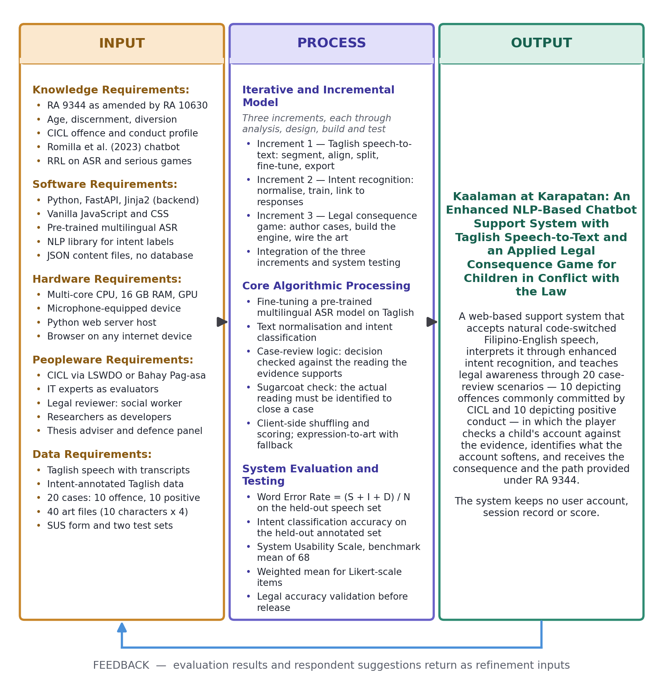
Figure 2.1 Conceptual Framework of the Study (Input-Process-Output Model)

As shown in Figure 2.1, the first frame represents the Input, consisting of the knowledge, software, hardware, peopleware and data requirements needed to enhance the existing system: the provisions of RA 9344 as amended by RA 10630 together with related penal statutes, which serve as the legal basis for the game storyboards; the profile of offenses commonly committed by CICL, which determines the scenarios depicted; the existing chatbot of Romilla et al. (2023) and its knowledge base; Taglish speech samples; a pre-trained multilingual ASR model; the NLP and game development frameworks with the necessary hardware and software; the evaluation instruments, namely the SUS questionnaire and the annotated test sets for WER and intent accuracy; and the people the study depends on, namely the CICL respondents reached through a partner institution, the IT experts who assess technical usability, and the qualified reviewer who validates the legal accuracy of every case before it is released.

The second frame represents the Process, the activities that transform these inputs into the enhanced system. It begins with requirements analysis and system design, then proceeds along three development tracks: fine-tuning the pre-trained ASR model on Taglish speech data, retraining the chatbot's intent recognition on transcribed Taglish utterances, and developing the legal consequence game from at least ten storyboards into case-review scenario modules. The modules are then integrated and tested, and the process concludes with the evaluation of WER, intent classification accuracy, and SUS ratings.

The third frame represents the Output, the enhanced NLP-based chatbot support system for CICL, equipped with a Taglish speech-to-text module that accepts natural code-switched spoken input and an applied legal consequence game composed of at least ten storyboard-based scenario modules.

Finally, the arrow at the bottom represents the Feedback loop. Evaluation results and respondent suggestions are returned as new inputs for iterative refinement, so that deficiencies in transcription accuracy, intent understanding, storyboard content and legal accuracy, or usability inform corrective revisions before the final version is produced.

Chapter Three

METHODOLOGY

3.1 Research Design

This study employs applied and developmental research, as its goal is to produce and evaluate a working software artifact, the enhanced NLP-based chatbot support system, rather than to test a hypothesis about an existing population. The developmental effort is guided by a defined software development model, and the resulting system is evaluated quantitatively using the metrics defined in Chapter 1.

3.1.1 Software Development Model

The study adopts the Agile methodology to guide development, cycling each increment through six phases: Plan, Design, Develop, Test, Deploy, and Review, before the complete system is Launched. The framework fits this study for two reasons. First, the enhancement consists of three components that can each be planned, designed, built, tested and deployed in their own turn through the cycle before integration: the Taglish speech-to-text module, the enhanced NLP intent recognition, and the applied legal consequence game. Second, the study's conceptual framework already defines an evaluation-driven feedback loop, and the Review phase operationalizes that loop by returning findings to the Plan phase of the next cycle. Figure 3.1 presents the model.

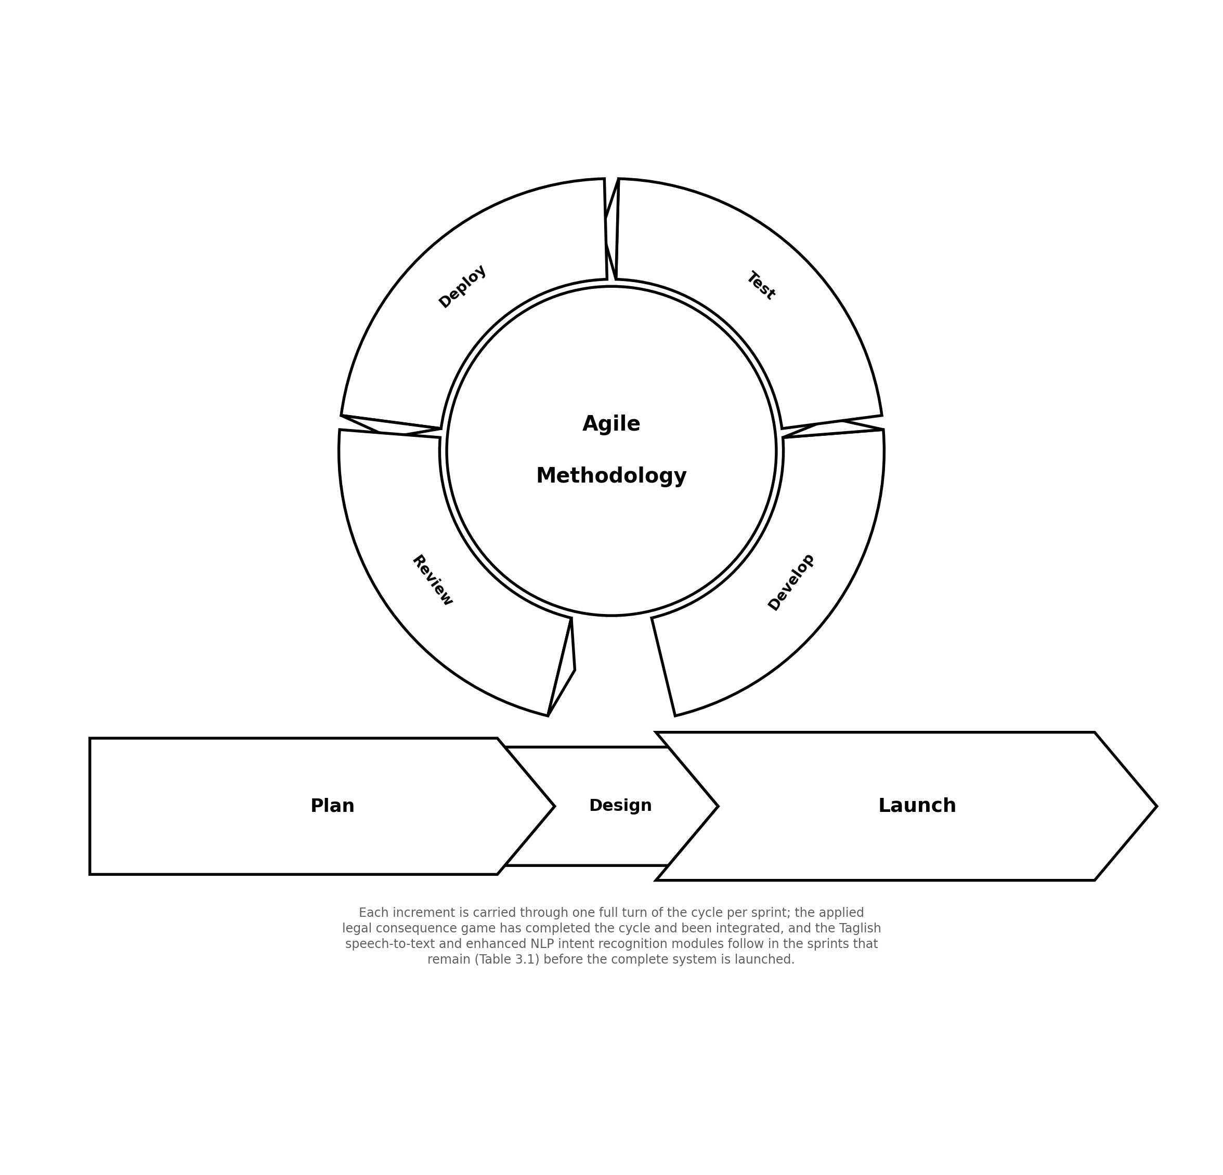
Figure 3.1 Agile Methodology of the Study

Each sprint carries the increment currently in development through one full pass of this cycle; sprint length is compressed to one week for the period between the title's acceptance and the panel defense. Table 3.1 presents the sprint schedule of the study, listing the sprint dates, goals, and status as of the writing of this manuscript. The applied legal consequence game, the third increment, has been carried through the cycle and integrated, and awaits the panel's feedback at defense; the Taglish speech-to-text module, the enhanced NLP intent recognition module, system integration, and the evaluation activities described in Section 3.4 remain on the backlog for the sprints that follow this defense, ending in the Launch of the complete system.

Table 3.1 Sprint Schedule of the Study
Sprint | Dates | Sprint Goal / Backlog Items | Status
— | Title Presentation and Acceptance — July 3, 2026
Sprint 1 | Jul 6–10, 2026 | Project inception: legal research (RA 9344, RA 10630), stakeholder consultation with the partner institution, and product backlog creation. | Completed
Sprint 2 | Jul 13–17, 2026 | System-wide design: four-tier architecture, use case diagram, and Level 0 context diagram. | Completed
Sprint 3 | Jul 20–24, 2026 | Case content data model and the case-authoring / legal-validation workflow. | Completed
Sprint 4 | Jul 27–31, 2026 | Applied Legal Consequence Game: booth engine (client-side game logic) — build. | Completed
Sprint 5 | Aug 3–7, 2026 | Applied Legal Consequence Game: ten storyboard-based scenario modules authored and tested. | Completed
Sprint 6 | Aug 10–14, 2026 | Applied Legal Consequence Game: integration and first-pass validation. | Completed, pending panel feedback
Sprint 7 | Aug 17–21, 2026 | Manuscript: Chapters 1–3 (Introduction, Review of Related Literature, Methodology) drafted and revised. | Completed
Sprint 8 | Aug 24–28, 2026 | Manuscript revisions and defense preparation: slide deck and a run-through of the game-module demo. | Completed
Sprint 9 | Aug 31–Sep 4, 2026 | Final proofreading and adviser sign-off ahead of the panel defense. | In Progress (current sprint)
— | Title / Proposal Defense — September 8–13, 2026 (Chapters 1–3 and a demo of the applied legal consequence game)
Sprint 10+ | To be scheduled after the defense, pending panel feedback | Taglish speech-to-text development, enhanced NLP intent recognition development, full system integration, and the Word Error Rate, intent classification accuracy, and System Usability Scale evaluations described in Section 3.4. | Planned

3.1.2 Respondents and Sampling

The system is evaluated by two respondent groups. The first consists of intended users, drawn with the assistance of a partner institution handling CICL (for example, a Local Social Welfare and Development Office or a Bahay Pag-asa), whose participation is governed by that institution's consent and child-protection protocols. The second consists of IT experts who assess technical usability. Purposive sampling is used for both groups, since respondents must meet defined criteria rather than represent a general population. The final sample size is subject to the access and child-protection constraints of the partner institution.

3.1.3 Research Instruments

Three instruments are used: (1) the System Usability Scale (SUS), a ten-item standardized questionnaire producing a 0 to 100 usability score, administered after a structured interaction that covers both the chat interface and a complete game session; (2) a Taglish speech test set, a collection of recorded utterances with manually verified reference transcriptions, used to compute Word Error Rate; and (3) an annotated intent test set, a collection of transcribed Taglish utterances labeled with their correct intents, used to measure intent classification accuracy. The two test sets are held as files and are run against the system offline; the system itself records no respondent data, for the reasons given in Section 3.2.

3.1.4 Data Gathering Procedure

Development data are gathered first. The Taglish speech corpus for adapting the ASR model is collected under consent and anonymized, and the legal content of the game is authored into the case content file and validated for legal accuracy by a qualified reviewer before any case is released for play. After each increment is built and the integrated system is ready, evaluation data are gathered: the speech and intent test sets are run against the system to obtain Word Error Rate and intent classification accuracy, and respondents interact with the system before completing the SUS questionnaire.

3.2 Proposed Algorithm and Proposed System Architecture
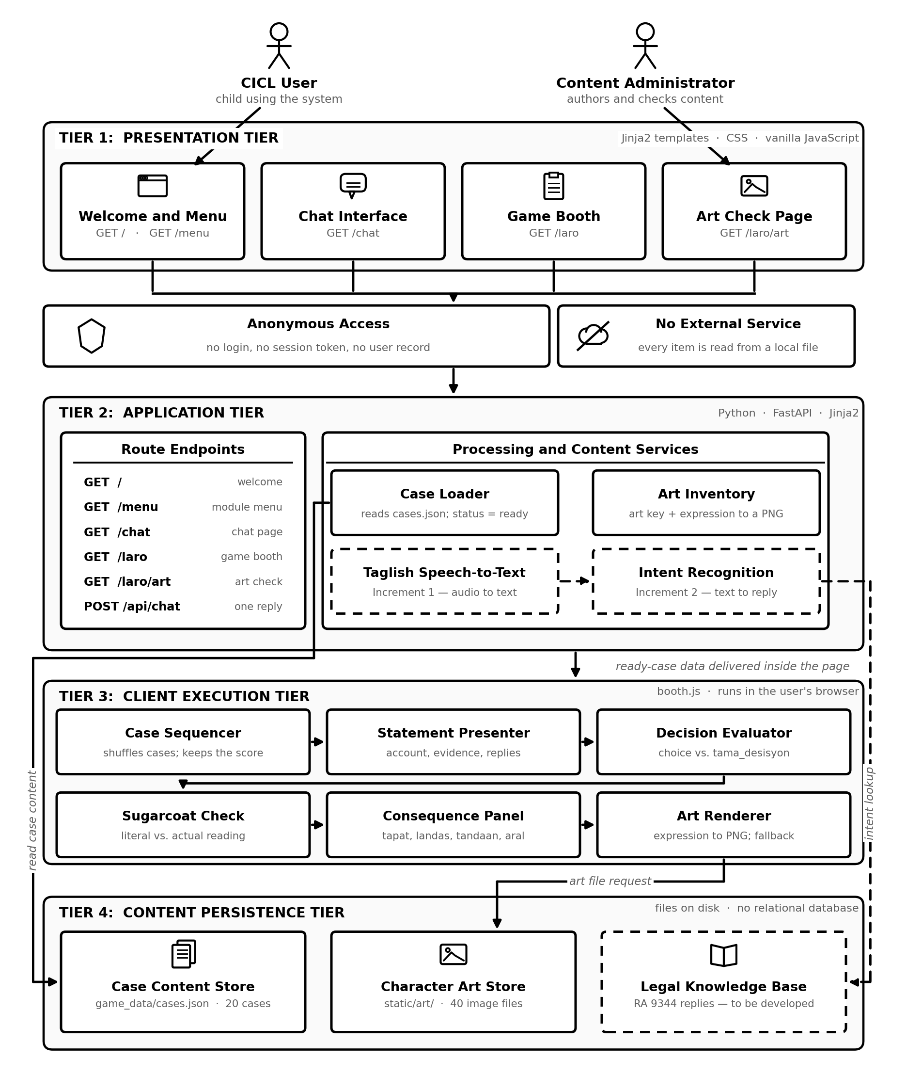
Figure 3.2 System Architecture

The enhanced system is built as a single web application, deployed under the working name Kaalaman at Karapatan, and is organized into four layers: a presentation layer of server-rendered pages, an application layer built on the FastAPI framework, a game engine that executes inside the user's own browser, and a content layer of plain files on disk. Two properties of this arrangement matter for the study. First, every legal statement, narrative line and lesson the child reads is held in an editable content file rather than in program code, so that a social worker or barangay official can correct the material without touching the application. Second, the system holds no user account, login or persistent record of any kind, which makes the child-protection posture described in Chapter 1 an architectural fact rather than a policy undertaking. Figure 3.2 presents the architecture.

As shown in Figure 3.2, components drawn with a solid outline are implemented and running, while components drawn with a dashed outline are specified by this study and are produced by the first and second increments. The four layers divide as follows.

Presentation Layer. The presentation layer consists of four server-rendered pages built as Jinja2 templates with a single stylesheet and vanilla JavaScript, with no front-end framework. The welcome page and the menu, served at GET / and GET /menu, introduce the system and route the child to one of the two modules. The chat interface at GET /chat carries the conversational exchange. The game booth at GET /laro carries the applied legal consequence game and is the only page delivered with its data already inside it: the router serializes the playable cases into the document, so that a complete session runs without a further request to the server. The art verification page at GET /laro/art lists every character expression the case file expects and marks each one as present or missing; it exists so that the content administrator can confirm that the artwork is complete before an evaluation session.

Application Layer. The application layer is a FastAPI server. Its router matches each URL to a handler, renders the corresponding template, and injects the playable-case data into the game page. Three services sit behind the router. The case loader reads the case content file and returns only those cases whose status field is marked ready, which allows unfinished cases to remain in the same file without ever reaching a player. The art inventory resolves a character key and an expression name to a file path under the art directory and reports which of the expected files exist. The chat response endpoint accepts one message at POST /api/chat and returns one reply. Two further components are specified by this study: the Taglish speech-to-text module, which converts recorded speech into Taglish text, and the enhanced intent recognition module, which maps that text to an intent and selects the reply. Until those increments are delivered, the chat endpoint returns keyword-matched placeholder replies; the two modules replace that placeholder rather than sit beside it.

Game Engine Layer. The applied legal consequence game executes in the browser rather than on the server. Once the game page has been delivered, the engine carries the whole session. The case sequencer shuffles the playable cases and keeps the current index and the score. The statement and questioning presenter types out the child's account, renders the evidence cards, and reveals the child's answer to each question the player asks. The decision evaluator compares the player's decision with the reading the case records as correct. The sugarcoat reading check presents the literal and the actual reading of the account and does not close the case until the actual reading is chosen. The consequence presenter renders what really happened, the path the law provides, the reminder addressed to the child, and the lesson. The character art renderer maps the current expression to an image file, pre-loading all four expressions of a character before that character appears and falling back to the neutral expression, and then to a drawn placeholder, when a file is absent. Because the engine is client-side, a session produces no server request after the page is delivered and therefore leaves no trace on the host.

Content Layer. The content layer is made of files, not tables. The case content store holds twenty cases: ten depicting offences commonly committed by CICL and ten depicting acts of positive conduct. The character art store holds the artwork as ten characters in four expressions each, named so that a character key and an expression name resolve directly to a filename. A third store, the legal knowledge base that will back the chat replies, is specified by this study and is not yet populated. The system uses no relational database. No user account, session identifier, transcript or score is written to disk at any point in a session; the running score exists only in the browser's memory and is discarded when the page is closed. Anonymity is therefore not a matter of what the system chooses not to record, but of the absence of any facility for recording it.

3.2.1 System Flowchart

Figure 3.3 presents the system flowchart, which traces the path a user takes from opening the application to the close of a session.

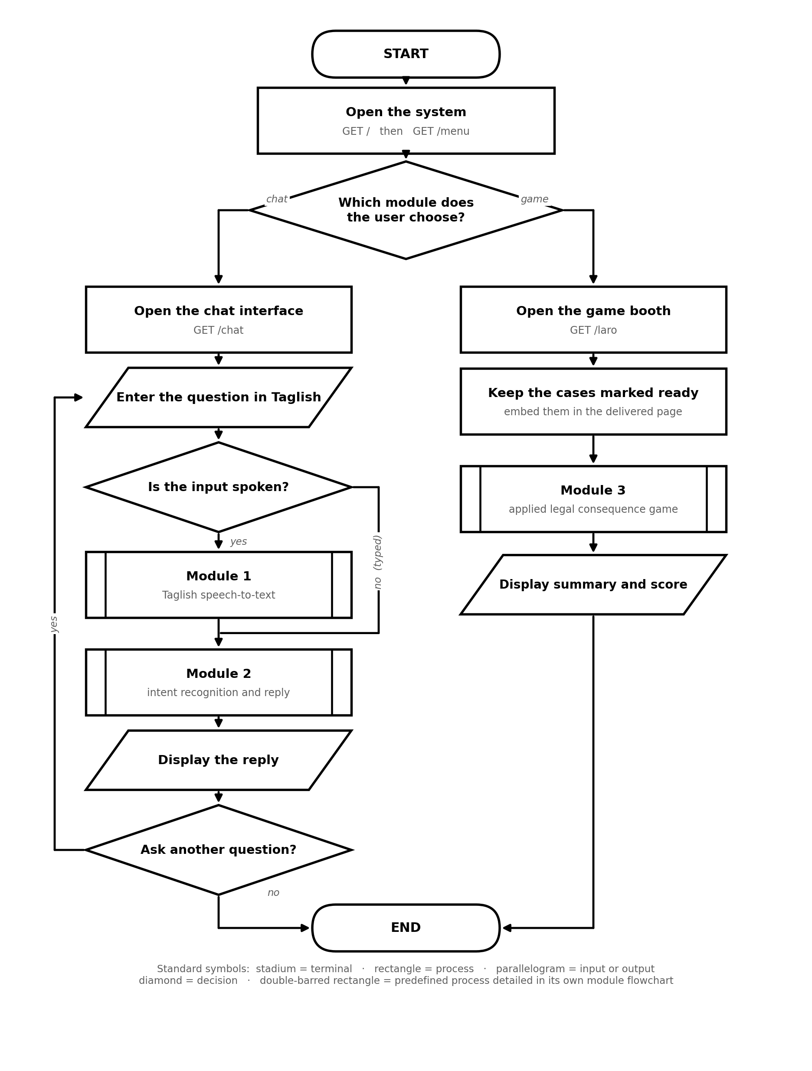
Figure 3.3 System Flowchart

The workflow presented in Figure 3.3 proceeds as follows:

1. Entry. The user opens the welcome page and moves to the menu, where the two modules are offered. No login, registration or identification of any kind is requested.

2. Module selection. The menu routes the user either to the chat interface or to the game booth. The two paths are independent and either may be used on its own.

3. Chat path, capture. The user asks a question in Taglish, either by typing it or, once the first increment is delivered, by speaking it.

4. Chat path, transcription. Spoken input is converted to Taglish text by the speech-to-text module. Typed input bypasses this step and enters the pipeline directly as text.

5. Chat path, understanding and reply. The intent recognition module classifies the transcribed or typed utterance, the matching response is selected from the legal knowledge base, and the reply is rendered in the chat thread.

6. Game path, delivery. The request for the game booth causes the server to read the case content file, keep only the cases marked ready, and embed them in the page that is returned to the browser.

7. Game path, session start. The browser shuffles the delivered cases and shows the how-to-play panel, which states the player's role before the first case appears.

8. Game path, case review cycle. Each case is reviewed in turn through the cycle detailed in Figure 3.6, which is the algorithm at the centre of the third increment.

9. Close. When no case remains, the session summary and the final score are displayed and the user is returned to the menu. Nothing from the session is retained.

3.2.2 Module Flowcharts

The overall flowchart in Figure 3.3 refers to three predefined processes, each drawn with the double-barred rectangle and each expanded into a module flowchart of its own. The three modules correspond to the three increments of the development model presented in Figure 3.1. Module 1 and Module 2 are specified by this study and are delivered by the first and second increments; Module 3 is implemented and running. The four flowcharts use the same standard symbols throughout: the stadium marks the start and the end of a path, the rectangle a process, the parallelogram an input or an output, the diamond a decision, the double-barred rectangle a predefined process detailed elsewhere, and the small circle an on-page connector.

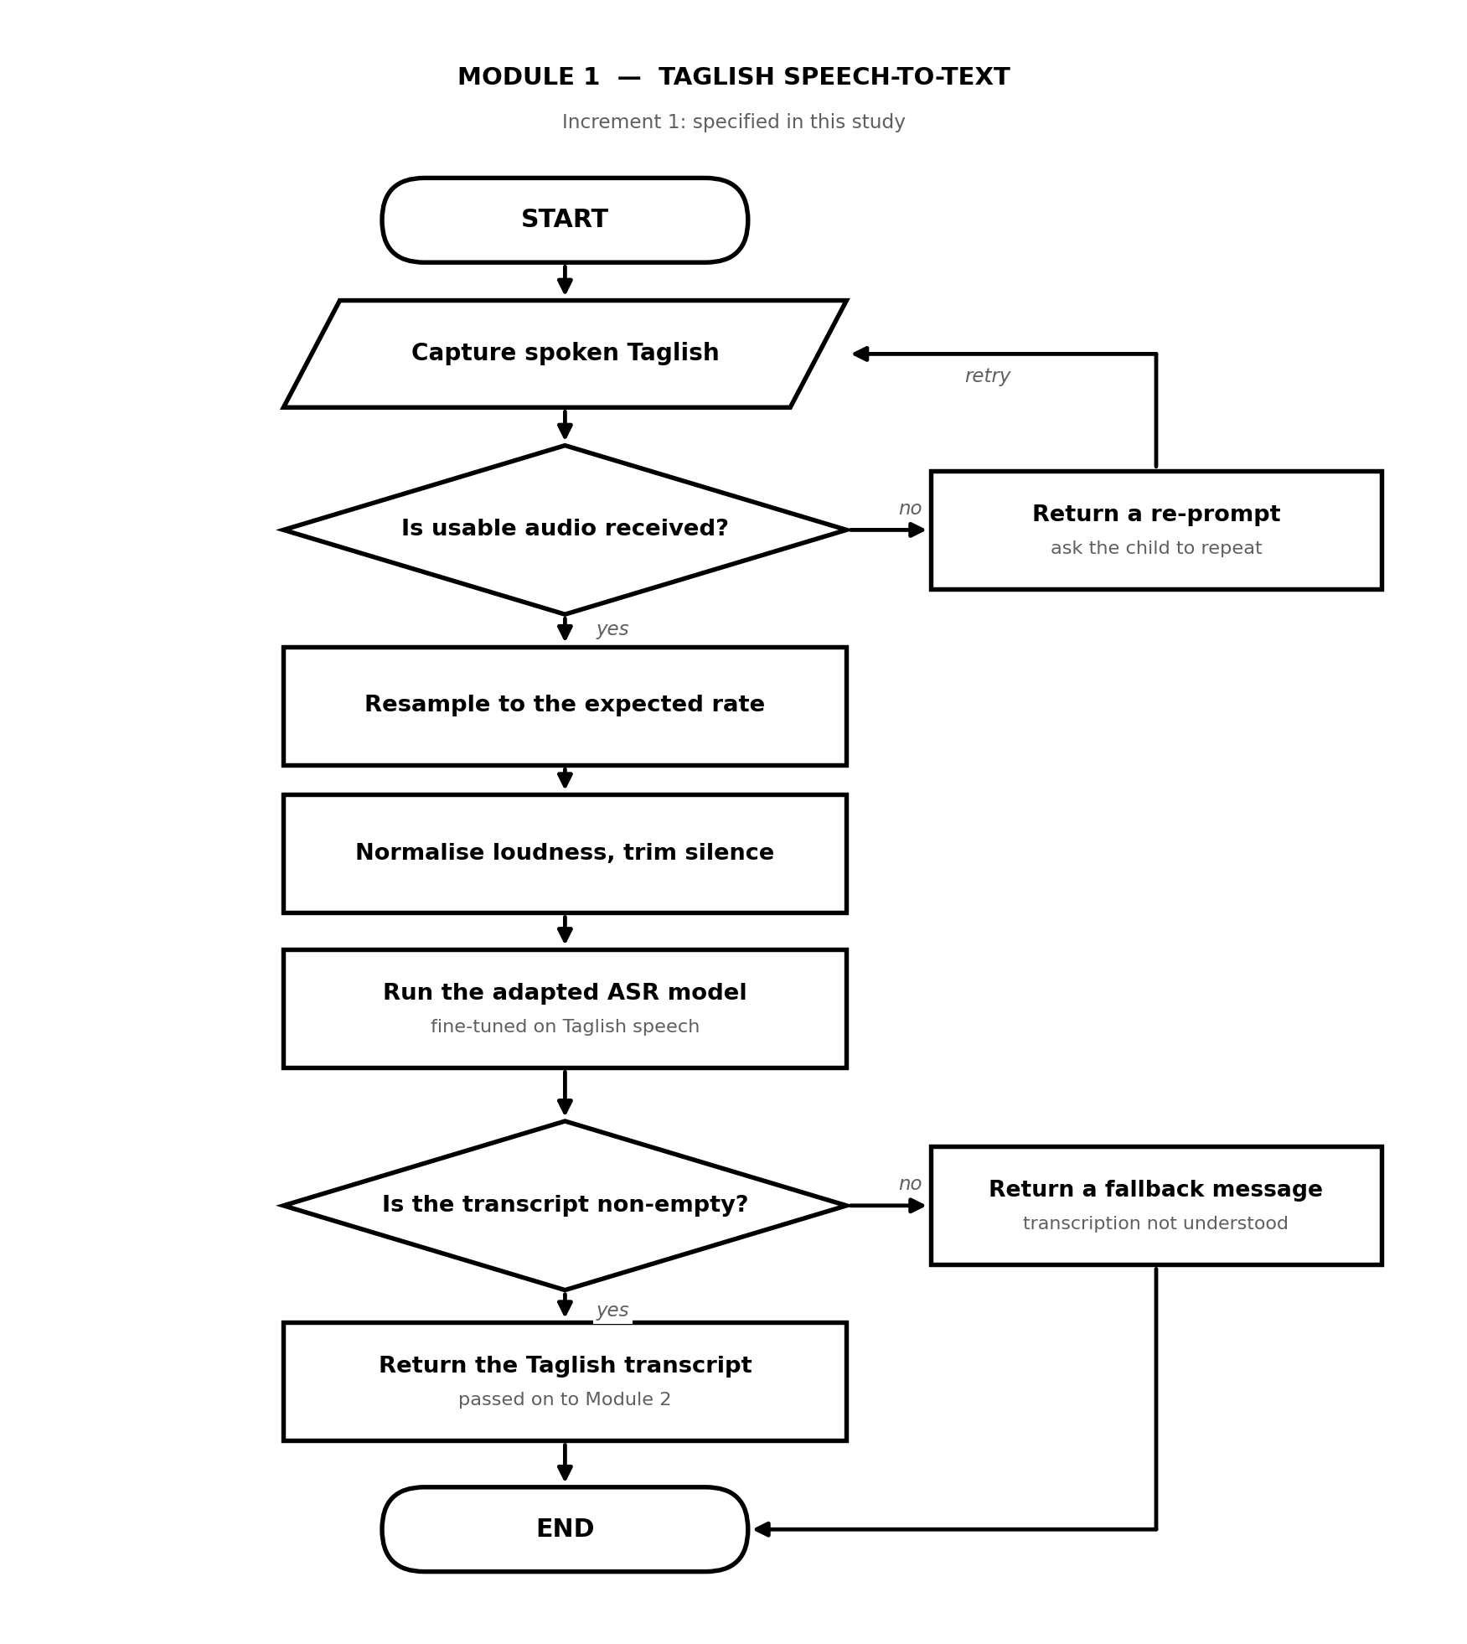
Figure 3.4 Module 1 Flowchart: Taglish Speech-to-Text

As shown in Figure 3.4, Module 1 begins when spoken Taglish is captured at the chat interface. The audio is first tested for usability; if nothing usable is received, a re-prompt asks the child to repeat and control returns to the capture step rather than to an error message. Usable audio is resampled to the rate the model expects, normalised for loudness and trimmed of leading and trailing silence, and passed to the adapted ASR model. The transcript is tested a second time: an empty transcript produces a fallback message stating that the utterance was not understood, and a non-empty transcript is returned as Taglish text for Module 2. Both recovery paths end the module without reaching Module 2, which is the reason the two decisions are drawn here rather than in the overall flowchart.

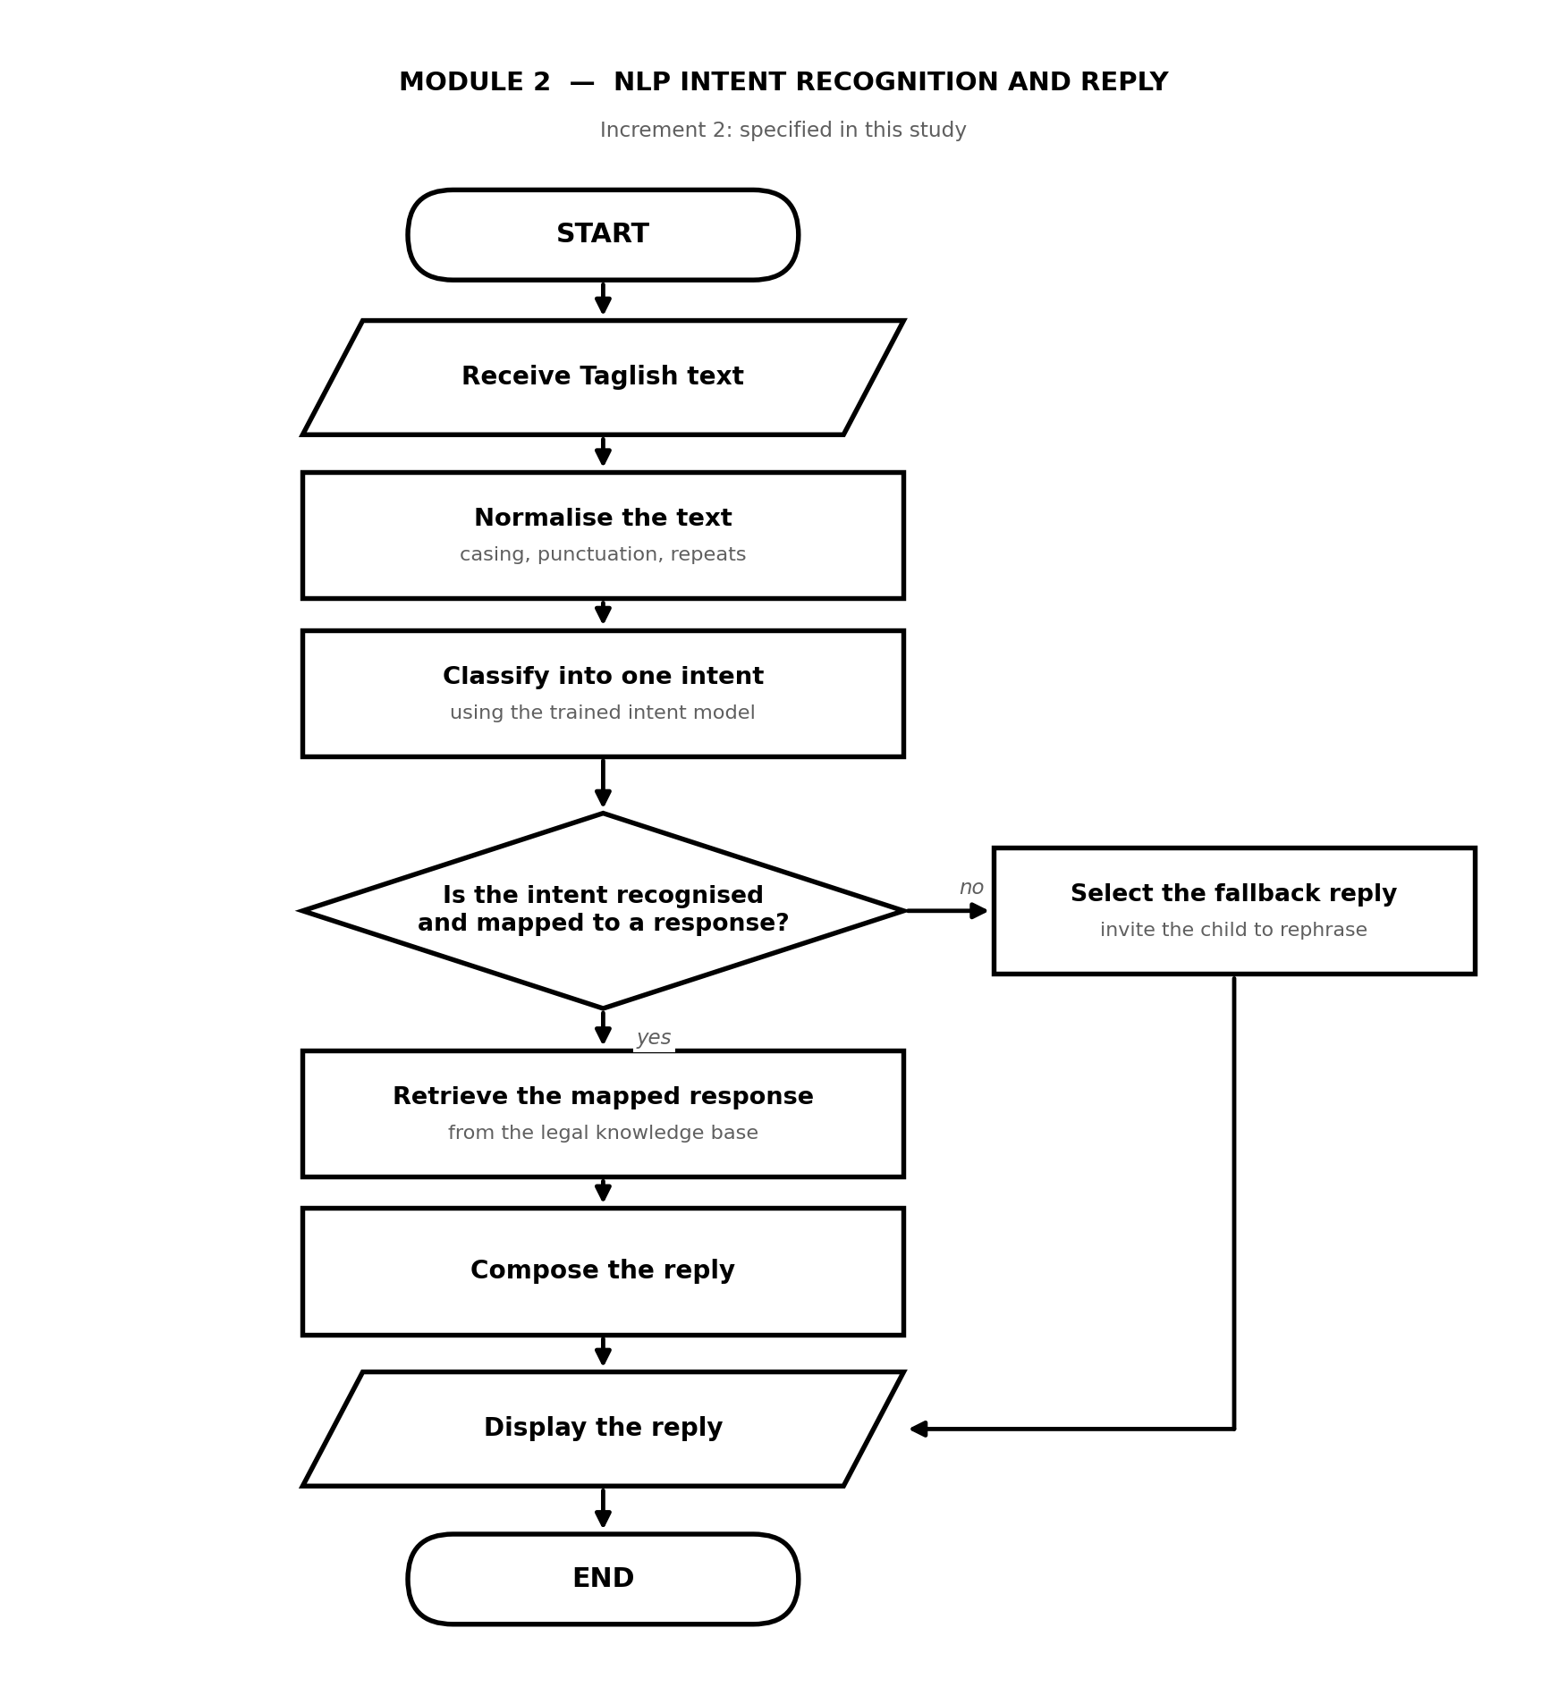
Figure 3.5 Module 2 Flowchart: NLP Intent Recognition and Reply

As shown in Figure 3.5, Module 2 receives Taglish text, whether it was transcribed by Module 1 or typed directly by the child, and applies the same normalisation of casing, punctuation and repeated characters that was applied to the training data. The trained intent model then assigns one intent to the utterance. A single decision governs the reply: if the intent is recognised and mapped to a response, the mapped entry is retrieved from the legal knowledge base and composed into a reply; if it is not, a fallback reply invites the child to rephrase. The two paths converge before the display step, so that the interface always returns something to the child rather than failing silently.

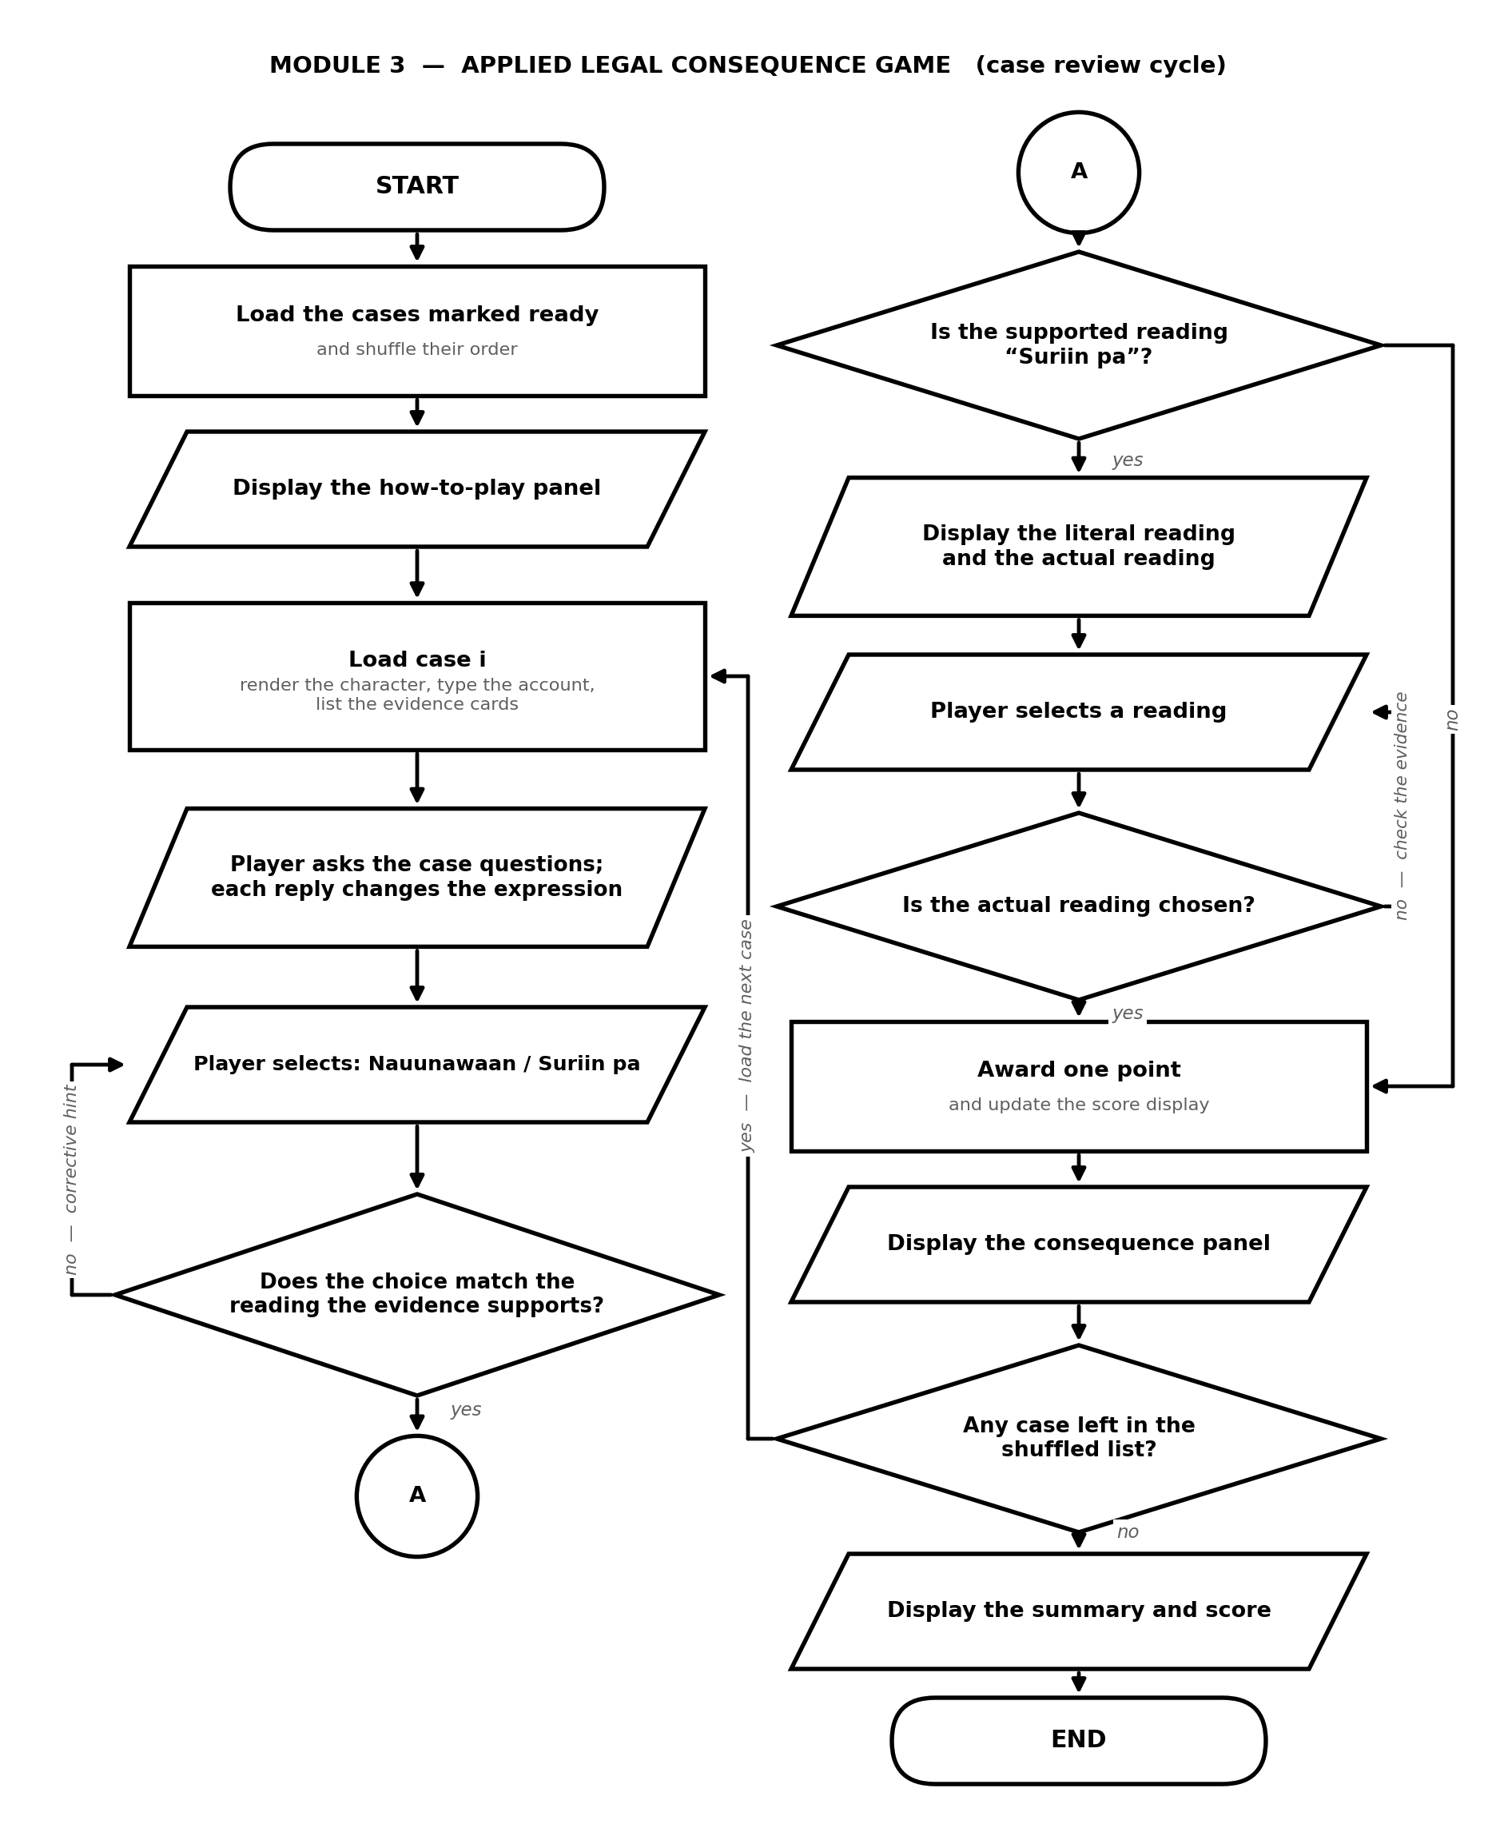
Figure 3.6 Module 3 Flowchart: Applied Legal Consequence Game

As shown in Figure 3.6, Module 3 is the case review cycle, repeated once for every case in the shuffled list. The flowchart is drawn in two columns joined by the on-page connector marked A, because the cycle contains four decision points and does not fit a single column. The first column carries the session set-up, the presentation of the case, and the player's decision on the child's account; the second carries the reading of the account, the scoring, the consequence panel, and the test for a remaining case. Two of the four decisions return control to an earlier step instead of advancing, which is the property that prevents a case from being passed by guessing. Section 3.4.3 follows the cycle step by step.

3.2.3 Use Case Diagram

Figure 3.7 presents the use cases of the system together with the two actors that exercise them.

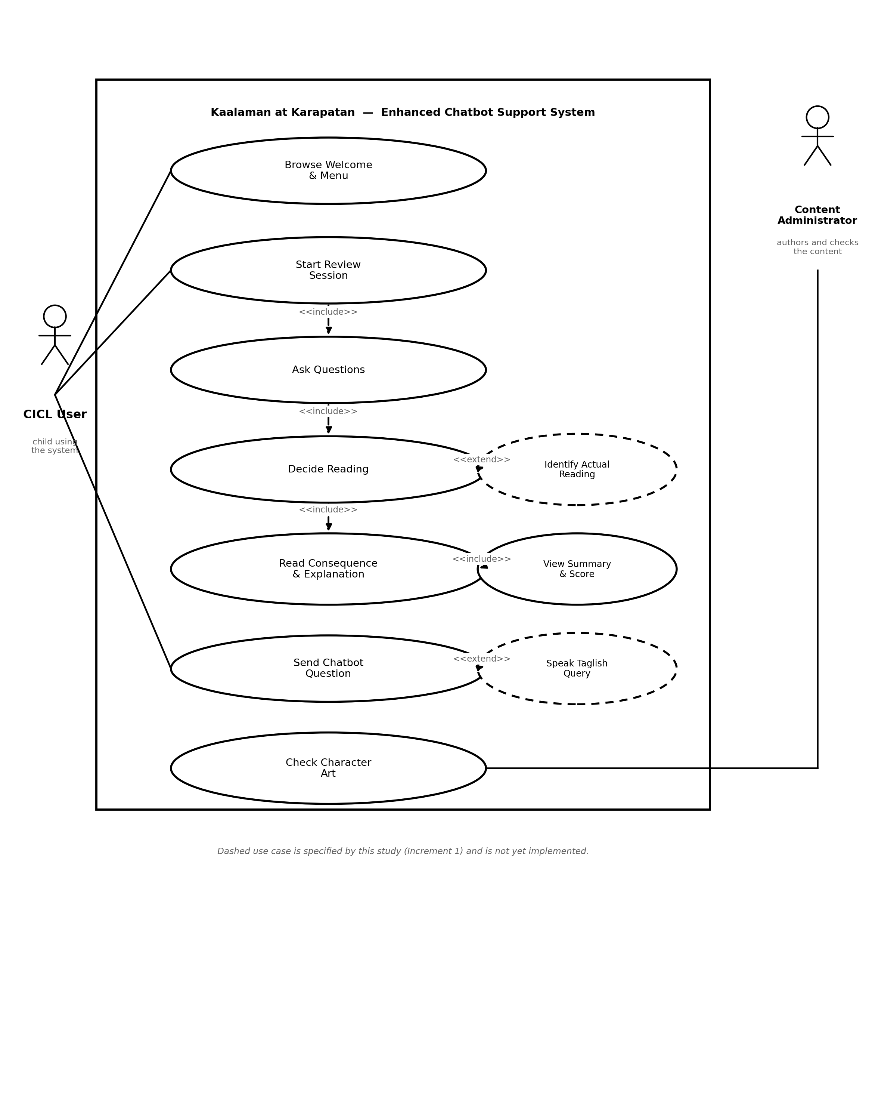
Figure 3.7 Use Case Diagram

As shown in Figure 3.7, the CICL user is the only actor who exercises the system's principal functions. The child browses the welcome page and menu, starts a case review session, asks the child in the case the questions the case provides, decides whether the account is clear or needs inspection, identifies the actual reading of a softened statement, reads the consequence and the accompanying RA 9344 explanation, views the session score and summary, and sends a typed question to the chatbot. Speaking a Taglish query is drawn with a dashed outline because it is delivered by the first increment. The system defines no login, no role and no privilege level: every visitor is the same anonymous user, and there is no use case for viewing another user's activity because no such activity is recorded.

The content administrator exercises exactly one use case inside the system boundary, namely checking through the art verification page that every character expression the case file expects is present. The remaining maintenance work, authoring case content and adding character art files, is performed directly on the content files and is therefore drawn outside the boundary: the application provides no administrative interface for it, and the diagram reports that fact rather than implying a console that does not exist. An administrative interface for content management and for the review of interaction logs is outside the present scope and is noted in Section 3.4.3 as a limitation of the current build.

3.2.4 Data Flow Diagram

Figure 3.8 presents the context diagram, which fixes the system boundary and the flows that cross it before any internal detail is shown. The data flow diagrams in this section follow the Gane and Sarson notation: a process is a rounded rectangle carrying its number in the upper compartment, a data store is a rectangle whose left compartment carries its identifier, and an external entity is a plain rectangle, marked with a corner stroke where the same entity is drawn more than once on one diagram.

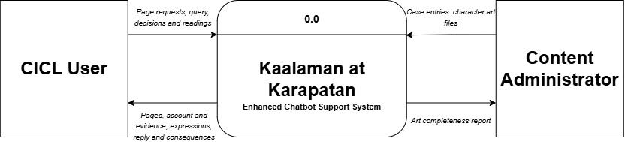
Figure 3.8 Level 0 Context Diagram

As shown in Figure 3.8, only two external entities interact with the system. The CICL user sends page requests, a spoken or typed query, and the decisions and reading selections made during a case, and receives the rendered pages, the child's account and the accompanying evidence, the character expressions, the chat reply, and the consequence and running score. The content administrator supplies the case entries, namely the narrative, the sugarcoat text and the correct reading, together with the character art files, and receives the art completeness report, which states which character images are present and which are still missing. That report is a maintenance readout rather than content: nothing returned to this entity reaches the child, and the system issues it no decision, recommendation or advice of any kind. No third external entity appears, because at run time the system calls no external service, no authentication provider and no remote model endpoint: every item it serves is read from a file on the same host. This is a consequence of the architecture described in Section 3.2 and is the reason the context diagram is deliberately narrow.

The single process of the context diagram is expanded into five level 1 data flow diagrams, one for each statement of the problem, so that the processes belonging to an objective can be read against that objective. The five diagrams share one set of data store identifiers, so that a store carrying the same identifier in two diagrams is the same store: D1 is the Taglish speech corpus, D2 the adapted ASR model, D3 the intent-annotated data, D4 the trained intent model, D5 the legal knowledge base, D6 the case content store, D7 the character art store, and D8 the evaluation records. Of these, D6 and D7 exist and are populated; the remainder are produced by the increments and by the evaluation described in Sections 3.4.1, 3.4.2, 3.4.4 and 3.4.5.

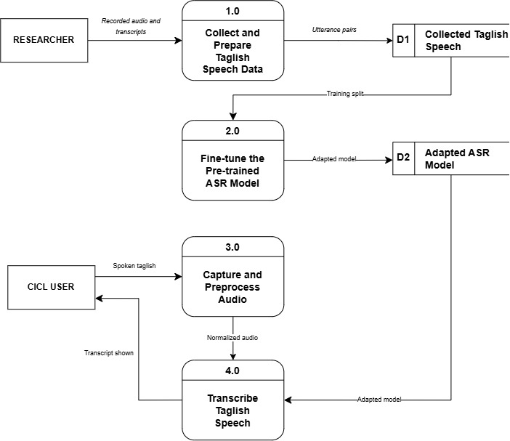
Figure 3.9 Level 1 Data Flow Diagram: SOP 1, Taglish Speech-to-Text

Figure 3.9 presents the level 1 data flow diagram for the first statement of the problem. Process 1.0 collects and prepares the Taglish speech data supplied by the researcher and writes the utterance pairs to D1. The training split of D1 feeds process 2.0, which fine-tunes the pre-trained ASR model and writes the result to D2. At run time, process 3.0 captures and preprocesses the audio spoken by the CICL user and passes normalised audio to process 4.0, which reads the adapted model from D2 and produces the Taglish transcript shown to the CICL user. The diagram therefore holds the development track and the run-time track of the same module in a single view, which is what distinguishes it from the module flowchart in Figure 3.4.

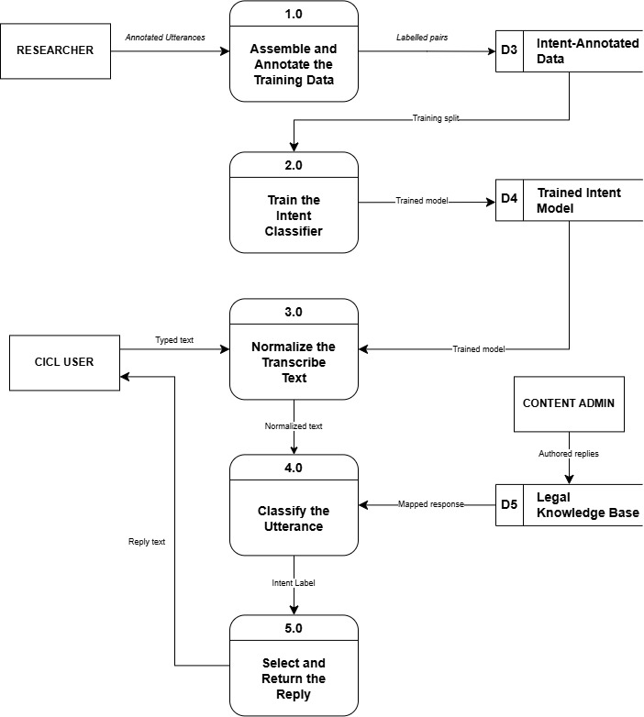
Figure 3.10 Level 1 Data Flow Diagram: SOP 2, Enhanced NLP Intent Recognition

Figure 3.10 presents the level 1 data flow diagram for the second statement of the problem. Process 1.0 assembles and annotates the training data into D3, and the training split feeds process 2.0, which trains the intent classifier into D4. At run time, process 3.0 normalises the transcribed or typed text, process 4.0 reads the trained model from D4 and classifies the utterance, and process 5.0 reads the mapped response from D5 and returns the reply text to the CICL user. The content administrator appears on this diagram as the source of the authored replies held in D5, which is the only point at which authored content enters the chat module.

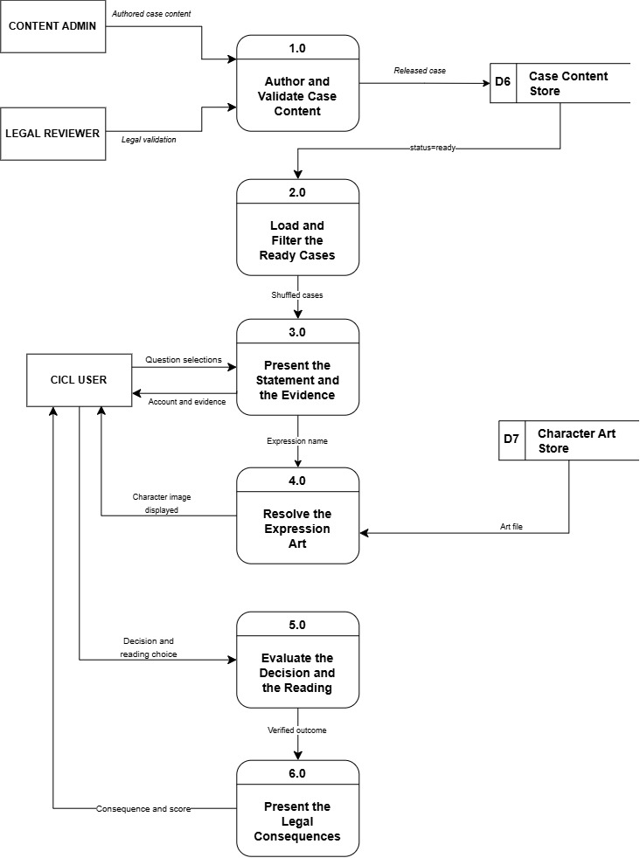
Figure 3.11 Level 1 Data Flow Diagram: SOP 3, Applied Legal Consequence Game

Figure 3.11 presents the level 1 data flow diagram for the third statement of the problem. Process 1.0 receives the authored case content from the content administrator and the legal validation from the legal reviewer, and writes a released case to D6. Process 2.0 loads D6 and keeps only those cases whose status is ready. Process 3.0 presents the child's account and the evidence to the CICL user and passes the current expression name to process 4.0, which resolves it against D7 and displays the character image directly to the CICL user. The player's decision and reading choice pass to process 5.0, which evaluates them, and the verified outcome passes to process 6.0, which presents the legal consequence and the running score. Process 1.0 is the only point at which the legal reviewer touches the system, and it is the mechanism by which no case reaches a child before it has been validated.

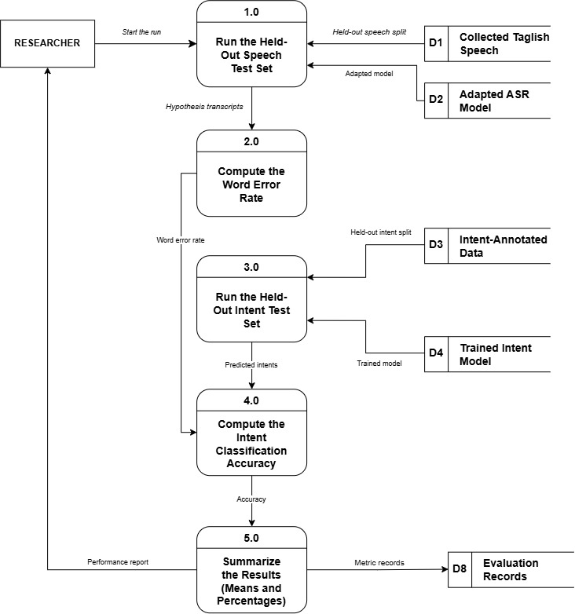
Figure 3.12 Level 1 Data Flow Diagram: SOP 4, System Performance Evaluation

Figure 3.12 presents the level 1 data flow diagram for the fourth statement of the problem. Process 1.0 runs the held-out speech split of D1 against the adapted model in D2, and process 2.0 aligns each hypothesis with its reference and counts the substitutions, insertions and deletions to yield the Word Error Rate. Process 3.0 runs the held-out intent split of D3 against the trained model in D4, and process 4.0 computes the intent classification accuracy. Process 5.0 summarises both metrics and writes them to D8. Because the running system records nothing, every flow on this diagram originates from a held-out test set rather than from a live session, which is the practical consequence of the absence of logging described in Section 3.2.

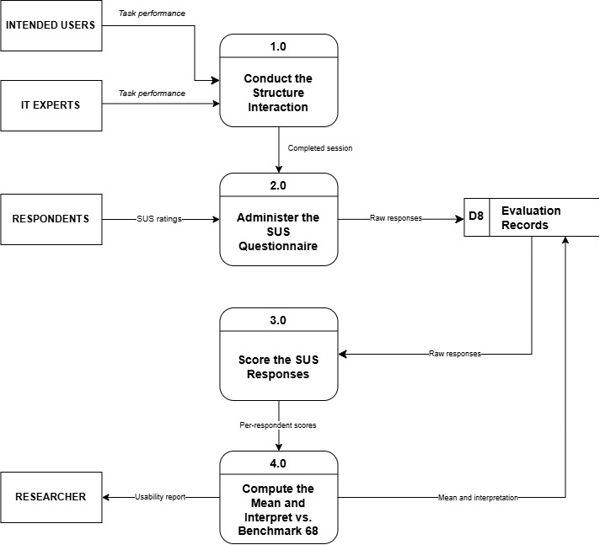
Figure 3.13 Level 1 Data Flow Diagram: SOP 5, Usability and Acceptability Evaluation

Figure 3.13 presents the level 1 data flow diagram for the fifth statement of the problem. Process 1.0 conducts the structured interaction with the intended users and the IT experts, process 2.0 administers the System Usability Scale and writes the raw responses to D8, process 3.0 scores those responses, and process 4.0 computes the mean and interprets it against the benchmark score of 68, returning the usability report to the researcher and writing the interpretation back to D8. The respondents are drawn a second time, with the corner stroke that marks a duplicated entity, because the same people who perform the structured interaction also supply the ratings.

3.2.5 Content Data Model

The system stores no user data and uses no relational database, so an entity relationship diagram in the conventional sense, with tables, primary keys and foreign keys, does not describe it. What the system does have is a structured content model: a single case file whose entries carry the narrative, the evidence, the reading options and the legal explanation for each case, together with a naming rule that binds a case to the artwork of its character. Figure 3.7 presents that model.

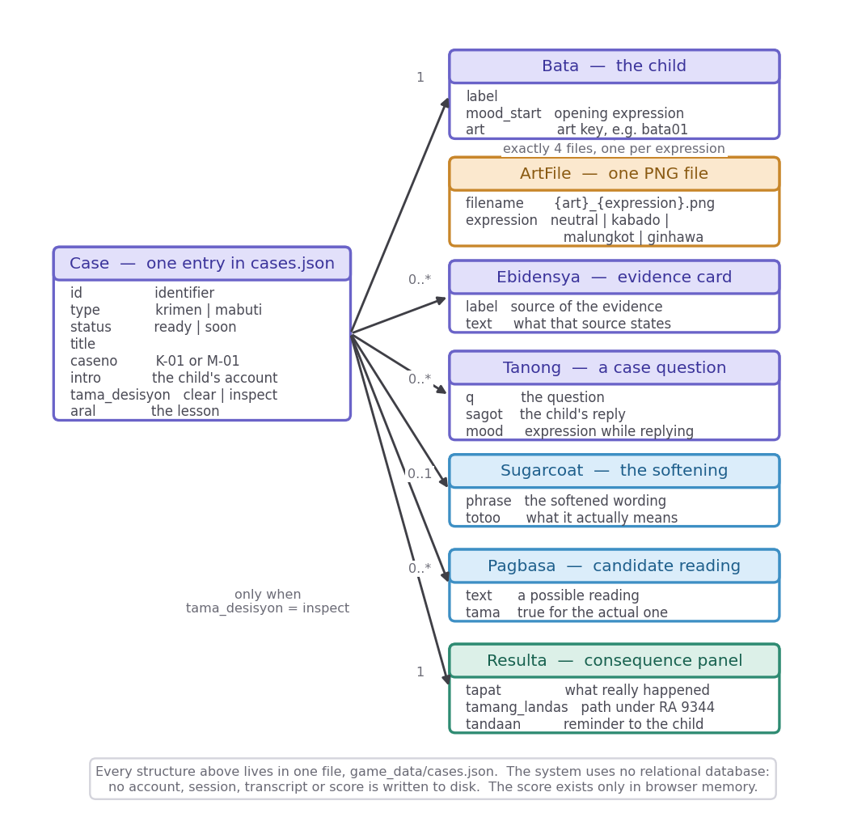
Figure 3.14 Content Data Model of the Case File

As shown in Figure 3.14, the Case is the root structure. It carries an identifier, a type that marks the case as depicting either an offence or an act of positive conduct, a status that controls whether the case is released for play, a title and a case number, the child's spoken account, the reading the evidence supports, and the lesson of the case. Each case has exactly one Bata, the child in the case, which names the opening expression and the art key. Each case has zero or more Ebidensya entries, the evidence cards that record the source and what that source states, and zero or more Tanong entries, each pairing a question the player may ask with the child's reply and the expression the child shows while giving it. Each case has at most one Sugarcoat, which records the softened wording and what that wording actually denotes, and, where the case requires inspection, a set of Pagbasa entries, of which exactly one is marked as the actual reading. Each case has exactly one Resulta, carrying what really happened, the path the law provides, and the reminder addressed to the child.

The relationship between a character and its artwork is a naming rule rather than a stored reference: the art key of the Bata combined with one of the four expression names resolves to a file in the art directory, so ten characters correspond to forty image files. Every structure shown in Figure 3.7 resides in one file. Because no session, transcript or score is written, the data model contains no entity that could identify a child, which is the property Chapter 1 requires of a system used with CICL.

3.3 System Requirements

3.3.1 Hardware Requirements

The requirements divide between the development environment and the end-user environment. Development and model adaptation require a machine with a multi-core processor, at least 16 GB of RAM, and, for efficient fine-tuning of the pre-trained ASR model, a CUDA-capable GPU; speech data collection additionally requires a microphone. Deployment requires a host able to run a Python web server. The end-user environment is deliberately light: because the game engine is plain JavaScript and the pages carry no heavy assets beyond the character images, the system runs on any internet-enabled device with a modern browser, and no GPU, installation or local configuration is required of the child. A microphone is required only for the speech input path.

3.3.2 Software Requirements

Python is the primary language. The web application is built on the FastAPI framework and served through an ASGI server, with Jinja2 for template rendering and the case content and character art served as static files; no database engine is required. The applied legal consequence game is implemented in vanilla JavaScript and CSS with no front-end framework or game engine, which keeps the whole game auditable as source text. The first increment requires a speech-recognition framework capable of fine-tuning a pre-trained multilingual ASR model, and a library for computing Word Error Rate from aligned transcriptions. The second increment requires an NLP library for training and serving the intent classifier.

The pre-trained ASR model adopted for fine-tuning is Whisper-small (Radford et al., 2023), accessed and adapted through the Hugging Face Transformers and Datasets libraries with PyTorch and CUDA acceleration, the same pipeline already validated end to end on the development machine and used to obtain the baseline Word Error Rate reported in Section 3.4.4. The intent classifier for the second increment is implemented with scikit-learn, pairing a TF-IDF vectorizer with a linear classifier trained on the transcribed Taglish utterances, which formalizes and extends the lightweight cosine-similarity approach used by the current placeholder classifier. Exact library and framework version numbers will be recorded once the development environment is finalized.

3.3.3 Dataset Requirements

Four datasets are required. The case content set consists of twenty authored cases, ten depicting offences commonly committed by CICL and ten depicting acts of positive conduct, each carrying its account, evidence, questions, reading options and legal explanation grounded in Republic Act No. 9344 as amended by Republic Act No. 10630. The character art set consists of forty transparent images, being ten characters in four expressions each. The Taglish speech dataset consists of recorded code-switched Filipino-English utterances with manually verified transcriptions, split into an adaptation portion and a held-out test portion. The intent-annotated Taglish dataset consists of transcribed utterances labeled with their correct intents, likewise split for training and testing.

The Taglish speech dataset targets a minimum of six hundred utterances collected from eight to fifteen adult proxy speakers standing in for the Taglish speech patterns of children in conflict with the law, consistent with the requirement in Chapter 1 that no actual minor be recorded. Utterances are elicited using a prepared script of one hundred twenty sentences covering code-switched Taglish phrasing relevant to RA 9344 rights and juvenile justice processes, recorded under consistent conditions and normalized to sixteen kilohertz mono; a thirty-utterance pilot batch has already been recorded and converted to validate the collection pipeline ahead of full-scale recording. The inventory of intents for the second increment spans the legal-topic intents already grounded in the knowledge base, among them the age of criminal responsibility, discernment, diversion, intervention, detention, confidentiality of records, civil liability, and the right to counsel, together with the conversational intents, greeting, thanks, and fallback, already piloted in the current placeholder classifier; the full inventory will be finalized once the intent-annotated dataset is assembled.

3.4 Theory, Methods, and Tools (per Objective)

This section describes, for each statement of the problem, how the objective is met and how the result is evaluated. Following the structure of the study's reference implementation, each objective is presented in terms of the process it follows, the tools it uses, and the system models that guide it.

3.4.1 SOP 1: Taglish Speech-to-Text Module

Process. A pre-trained multilingual ASR model is adapted to Taglish rather than trained from scratch, following the approach established in the literature reviewed in Section 2.1.1. Recorded Taglish speech is collected under consent, converted to a single sample rate and audio format, and segmented into individual utterances with a dataset manifest. Each utterance is paired with its manually verified reference transcription, and the set is split into an adaptation portion and a held-out test portion. The pre-trained model is fine-tuned on the adaptation portion, the adapted model is exported, and it is integrated behind the chat endpoint so that spoken input reaches the intent recognition module as Taglish text. Figure 3.4 presents the run-time flow of the module, and Figure 3.9 the data flow of its development and run-time tracks together.

Tools. Python, a speech-recognition framework capable of fine-tuning a pre-trained multilingual ASR model, and a library for computing Word Error Rate from aligned transcriptions. The exact model variant is recorded as information still needed in Section 3.3.2.

System Models. The module flowchart in Figure 3.4 and the level 1 data flow diagram in Figure 3.9, which together locate the module within the run-time system and identify the data stores it produces and consumes.

As shown in Figure 3.9, the adaptation portion and the held-out test portion are drawn from the same store, D1, but only the adaptation portion reaches process 2.0. The held-out portion is never seen during adaptation and is reserved for the evaluation described in Section 3.4.4, where it is transcribed by the adapted model, each hypothesis is aligned with its reference, and the substitutions, insertions and deletions are counted to yield the Word Error Rate reported for Objective 4.

3.4.2 SOP 2: Enhanced NLP Intent Recognition

Process. The chatbot's intent recognition is retrained on transcribed Taglish so that the gains obtained at the transcription level are preserved at the level of understanding. The intent-annotated Taglish utterances are assembled, normalized for casing, punctuation and repeated characters, and split into a training portion and a held-out test portion. The classifier is trained on the training portion and evaluated on the held-out portion. At run time the same normalization is applied to the transcribed utterance, the classifier assigns one intent, the response mapped to that intent is selected from the legal knowledge base, and the reply is returned to the chat interface. Figure 3.5 presents the run-time flow of the module, and Figure 3.10 the data flow of its training and run-time tracks together.

Tools. Python and an NLP library for training and serving the intent classifier, with the legal knowledge base held as a content file alongside the case content, so that the wording of legal replies remains editable by a reviewer.

System Models. The module flowchart in Figure 3.5 and the level 1 data flow diagram in Figure 3.10, in which data store D4 holds the trained intent model and data store D5 the legal knowledge base.

The data flow shown in Figure 3.10 makes explicit that the module replaces, rather than supplements, the keyword-matched placeholder currently returned by the chat endpoint. The placeholder is retained only so that the interface can be exercised during the development of the first and second increments.

3.4.3 SOP 3: Applied Legal Consequence Game

Process. The applied legal consequence game is implemented as a case-review booth. The player is not cast as the child; the player is cast as the person at the desk to whom a child brings an account, which is the position a social worker, barangay official or counsellor actually occupies in the diversion process. Each case presents a child who describes what happened in his or her own words, together with the testimony and documents that bear on it. The player may put the case questions to the child and observe the child's expression change with each answer, and must then decide whether the account is clear as given or whether it needs to be examined further. Where the account softens what happened, the case file records both the softened phrase and what that phrase actually denotes, and the player must identify the actual reading before the case closes. Only then does the case disclose what really happened, the path the law provides for it, the reminder addressed to the child, and the lesson.

This design is a change from the branching model described at the proposal stage, in which the player was cast as the child choosing inside a depicted offence and the choice was routed through the age-and-discernment test to a depicted outcome. That model was set aside for three reasons. It required a child in conflict with the law to rehearse the commission of an offence in order to learn its consequence. It reduced the law to a lookup on age, whereas the difficulty a CICL actually encounters is that an account of an event and the evidence for it do not agree. And it left no room to depict positive conduct at all. The case-review model addresses each of these: the child is depicted as someone whose account deserves to be heard and checked rather than someone whose offence is re-enacted; the legal explanation is delivered after the facts have been established, which is the order the law itself follows; and ten of the twenty cases depict acts of positive conduct, so that the same characters appear both as children who did wrong and as children who did right, which guards the material against presenting any one face as that of an offender. The remaining ten cases depict offences commonly committed by CICL, satisfying the requirement of at least ten storyboards stated in Chapter 1.

Figure 3.6 presents the review logic of a single case, which is the algorithm at the centre of this objective, and Figure 3.11 presents the corresponding data flow.

As shown in Figure 3.6, a session begins by loading the cases marked ready and shuffling their order, so that no two sessions present the same sequence. The how-to-play panel states the player's role, and the first case is loaded: the character is rendered in the opening expression the case specifies, the child's account is typed out, and the evidence cards are listed. The player may ask any of the questions the case provides, each of which reveals the child's reply and changes the character's expression. The player then commits to one of two decisions, that the account is understood as given or that it needs to be examined further. If the decision does not match the reading the evidence supports, the case does not advance: a corrective hint is shown and the decision is put again, so that the player cannot pass a case by guessing. If the decision is correct and the case is one that requires inspection, the literal and the actual reading of the account are presented and the player must select the actual reading, again with a prompt to re-examine the evidence on a wrong selection. Only when the correct outcome has been reached is a point awarded and the consequence panel shown. The cycle then repeats until the shuffled list is exhausted, after which the session summary and the final score are displayed.

Tools. The engine is written in vanilla JavaScript and CSS and runs in the browser. The case content is authored in a single JSON file and the character artwork in a directory of transparent images, both editable without touching program code. The art verification page and its accompanying command-line check report any expression file that is missing, misnamed or unreferenced, so that a case is never released for play with incomplete artwork.

System Models. The module flowchart in Figure 3.6, the level 1 data flow diagram in Figure 3.11, and the content data model in Figure 3.14.

The legal content of each case, namely the path under Republic Act No. 9344 as amended by Republic Act No. 10630 and the reminder addressed to the child, is authored into the case file and is validated for legal accuracy by a qualified reviewer, for example a social worker or barangay official, before the case is marked ready and becomes reachable by a player. At the present state of the build, all twenty cases carry complete content and are marked ready, so the case loader draws from the full set without withholding any from play. The legal knowledge base underlying the chat module has likewise been populated, holding grounded excerpts of Republic Act No. 9344, Republic Act No. 10630, and their Revised Implementing Rules and Regulations. The outstanding item of this increment is the intent classifier itself, described in Section 3.4.2, which presently runs on a hand-rolled placeholder rather than the library-trained model the objective calls for.

3.4.4 SOP 4: System Performance Evaluation

Process. Component performance is measured with two objective metrics. Word Error Rate is computed for the speech-to-text module from the substitutions, insertions and deletions counted between the system transcription and the reference transcription of the held-out speech test set, as shown in Figure 3.8. Intent classification accuracy is computed for the NLP module as the percentage of held-out annotated utterances mapped to their correct intent, as shown in Figure 3.9. Results are reported as descriptive statistics, namely means and percentages, with a per-condition breakdown where the test set permits it.

Tools. Python, a Word Error Rate library operating on aligned transcriptions, and standard data-analysis libraries for the summary tables and charts.

System Models. The level 1 data flow diagram in Figure 3.12, together with the stores D1 to D4 that it reads and the evaluation records in D8 that it writes. Because the running system records nothing, both metrics are obtained by running the held-out test sets against the modules offline rather than by mining logs of live use.

3.4.5 SOP 5: Usability and Acceptability Evaluation

Process. Usability and acceptability are measured using the System Usability Scale, administered to intended users and IT experts after a structured interaction covering both modules: a short exchange with the chat interface and a complete game session of the cases marked ready. SUS responses are scored with the standard formula to produce a 0 to 100 score per respondent, the mean SUS score is computed, and it is interpreted against the established acceptability benchmark of a mean of 68. The weighted mean is used to summarize any supplementary Likert-scale evaluation items.

Tools. The SUS questionnaire, administered on paper or through a form under the partner institution's consent and child-protection protocols, and spreadsheet or statistical software for scoring and summary.

System Models. The level 1 data flow diagram in Figure 3.13, and the use cases in Figure 3.7, which define the tasks respondents are asked to perform so that every SUS response refers to the same set of interactions.

Chapter Four

RESULTS AND DISCUSSION

This chapter presents the results of evaluating the enhanced system against the two evaluation objectives set out in Chapter 3: Word Error Rate and intent classification accuracy for the Taglish speech-to-text and intent recognition modules under Objective 4, and usability and acceptability under Objective 5, measured with the System Usability Scale administered to intended users and IT experts. The system is presently in development — the case-review booth is implemented and running, while the Taglish speech-to-text and enhanced intent recognition modules are specified but not yet built — so the tables in this chapter are structured to receive results once each evaluation activity is carried out, and are marked [RESULTS PENDING] where a figure cannot yet be reported.

4.1 Profile of Respondents

Table 4.1 presents the profile of the respondents who take part in the evaluation: the intended users, reached through the partner institution handling children in conflict with the law under that institution's consent and child-protection protocols, and the IT experts who assess technical usability. Respondent counts, roles, and any other profiling variable collected on the SUS administration form are reported once the evaluation session is conducted.

Table 4.1 Profile of Respondents
Profile Variable | Category | f | %
Respondent Group | Intended Users (CICL Respondents) | [RESULTS PENDING] | [RESULTS PENDING]
 | IT Experts | [RESULTS PENDING] | [RESULTS PENDING]
Age Range | [RESULTS PENDING] | [RESULTS PENDING] | [RESULTS PENDING]
Sex | [RESULTS PENDING] | [RESULTS PENDING] | [RESULTS PENDING]
Prior Exposure to the Existing Chatbot | Yes | [RESULTS PENDING] | [RESULTS PENDING]
 | No | [RESULTS PENDING] | [RESULTS PENDING]

4.2 Taglish Speech-to-Text Performance (Objective 4)

This section reports the Word Error Rate obtained by running the held-out test portion of the Taglish speech corpus against the adapted ASR model, following the procedure described in Section 3.4.1 and shown in Figure 3.9. Word Error Rate is computed as the sum of substitutions, insertions, and deletions between each hypothesis transcript and its manually verified reference, divided by the total number of words in the reference set:

WER = (S + I + D) / N × 100%,

where S is the number of substituted words, I the number of inserted words, D the number of deleted words, and N the total word count of the reference transcripts.

Table 4.2 Word Error Rate Results
Metric | Value
Number of held-out test utterances | [RESULTS PENDING]
Total reference word count (N) | [RESULTS PENDING]
Substitutions (S) | [RESULTS PENDING]
Insertions (I) | [RESULTS PENDING]
Deletions (D) | [RESULTS PENDING]
Word Error Rate | [RESULTS PENDING]

A lower Word Error Rate indicates closer agreement between the adapted model's transcription and what was actually said. The discussion in this section, once the figure is available, should relate the obtained rate to comparable Taglish or Filipino ASR results cited in Section 2.1 and to whichever error types (substitutions, insertions, or deletions) dominate, since that pattern points to what kind of speech the model still struggles with, for example code-switched phrases or background noise.

4.3 Enhanced Intent Recognition Performance (Objective 4)

This section reports the intent classification accuracy of the enhanced NLP module, obtained by running the held-out portion of the intent-annotated dataset against the trained intent classifier, following the procedure described in Section 3.4.2 and shown in Figure 3.10. Accuracy is computed as the proportion of held-out utterances assigned the correct intent:

Accuracy = (number of utterances correctly classified) / (total number of held-out utterances) × 100%.

Table 4.3 Intent Classification Accuracy Results
Metric | Value
Number of held-out test utterances | [RESULTS PENDING]
Utterances correctly classified | [RESULTS PENDING]
Overall Intent Classification Accuracy | [RESULTS PENDING]

Table 4.4 breaks this figure down per intent so that any intent the classifier confuses with another is visible on its own, rather than hidden inside a single overall percentage.

Table 4.4 Intent Classification Accuracy per Intent
Intent | Test Utterances | Correctly Classified | Accuracy
e.g., ask about RA 9344 | [RESULTS PENDING] | [RESULTS PENDING] | [RESULTS PENDING]
e.g., ask about diversion | [RESULTS PENDING] | [RESULTS PENDING] | [RESULTS PENDING]
e.g., ask how the game works | [RESULTS PENDING] | [RESULTS PENDING] | [RESULTS PENDING]
… | [RESULTS PENDING] | [RESULTS PENDING] | [RESULTS PENDING]

4.4 Usability and Acceptability (Objective 5)

This section reports the System Usability Scale results obtained from the structured interaction described in Section 3.4.5 and shown in Figure 3.13. Each respondent completes the standard ten-item SUS questionnaire immediately after the interaction; odd-numbered items are scored as (response − 1) and even-numbered items as (5 − response), the ten adjusted scores are summed, and the total is multiplied by 2.5 to yield a score on a 0-to-100 scale. Table 4.5 presents the mean SUS score per respondent group, and Table 4.6 interprets the overall mean against the adjective rating scale reported by Bangor, Kortum, and Miller (2009), which this study adopted in Chapter 2 together with the benchmark score of 68.

Table 4.5 Mean SUS Score per Respondent Group
Respondent Group | n | Mean SUS Score | Interpretation
Intended Users (CICL Respondents) | [RESULTS PENDING] | [RESULTS PENDING] | [RESULTS PENDING]
IT Experts | [RESULTS PENDING] | [RESULTS PENDING] | [RESULTS PENDING]
Overall | [RESULTS PENDING] | [RESULTS PENDING] | [RESULTS PENDING]

Table 4.6 SUS Score Range and Adjective Rating
SUS Score Range | Adjective Rating
84.1 – 100 | Best Imaginable
72.6 – 84.0 | Excellent
68.0 – 72.5 | Good
51.0 – 67.9 | OK
25.1 – 50.9 | Poor
0 – 25.0 | Worst Imaginable

A mean SUS score at or above 68 supports the claim that the system is at least average in perceived usability for its intended respondents; a score below that benchmark should be discussed against the qualitative feedback in Section 4.5 to identify which part of the interaction, the chat interface or the game booth, respondents found harder to use.

4.5 Qualitative Feedback from Respondents

In addition to the SUS items, respondents are asked open-ended questions on the features they found most useful, the difficulties they encountered, and improvements they would recommend. Table 4.7 summarises these responses once collected.

Table 4.7 Summary of Open-Ended Responses
Question | Respondent Feedback
What features did you find most useful? | [RESULTS PENDING]
What difficulties did you encounter? | [RESULTS PENDING]
What improvements would you recommend? | [RESULTS PENDING]
Any additional comments? | [RESULTS PENDING]

4.6 Summary of Results

[RESULTS PENDING] This section synthesises Sections 4.2 through 4.5 once all four results are available, stating plainly whether each of the study's two evaluation objectives (Objective 4: Word Error Rate and intent classification accuracy; Objective 5: usability and acceptability) was met, and noting any respect in which a result fell short of what Chapter 1 set out to achieve.
Chapter Five

CONCLUSIONS AND RECOMMENDATIONS
The thesis proposal and the thesis follow the same format, with the following exceptions:
- The title page is changed to reflect that this is a thesis proposal.
- A “recommendation sheet” with the adviser(s) signature is attached instead of an “approval sheet”. Signatures of the panel members, the chair and the dean are not required.
- There is no “Acknowledgements” section in the proposal nor is there an “Abstract”.
- There is no “Results and Discussion” section in the proposal, although a “Preliminary Results” section may be included.
- There is no “Conclusions and Recommendations” section in the proposal.
- The Appendix in the proposal contains additional data, information or picture relevant to the research. In the thesis, the Appendix contains supporting material for the thesis, such as raw data, calibration curves, etc.

LIST OF REFERENCES
Ajmi, A. (2024). Revolutionizing access to justice: The role of AI-powered chatbots and retrieval-augmented generation in legal self-help. The Brief, 53(3). American Bar Association.
Biro, A. V. S., Fernandes, J. A. S., Fernandes, S. M. P. S., Ribeiro, L. C. S., Almeida, G. C., & Almeida, G. C. (2025). Serious game as an educational tool to promote the health of children and adolescents with cancer. Investigacion y Educacion en Enfermeria, 43(1), e02. https://doi.org/10.17533/udea.iee.v43n1e02
Cajote, R. D., Guevara, R. C. L., Bayona, M. G. A. R., & Lucas, C. R. G. (2024). Philippine Languages Database: A multilingual speech corpora for developing systems for Philippine spoken languages. Proceedings of the 2024 Joint International Conference on Computational Linguistics, Language Resources and Evaluation (LREC-COLING 2024). European Language Resources Association.
Carvalho, I. S., Mendes, R. C. M. G., Lima, L. H. S. S., Silva, G. P., Lima, M. F. G., Guedes, T. G., & Linhares, F. M. P. (2023). Effect of a board game on imprisoned women's knowledge about sexually transmitted infections: A quasi-experimental study. BMC Public Health, 23. https://doi.org/10.1186/s12889-023-15646-3
Chien, C. V., & Kim, M. (2024). Generative AI and legal aid: Results from a field study and 100 use cases to bridge the access to justice gap. Loyola of Los Angeles Law Review, 57.
Cruz, J. C. B., & Cheng, C. (2022). Improving large-scale language models and resources for Filipino. Proceedings of the Thirteenth Language Resources and Evaluation Conference (LREC 2022), 6548-6555. European Language Resources Association.
Cruz, J. C. B., Resabal, J. K., Lin, J., Velasco, D. J., & Cheng, C. (2021). Exploiting news article structure for automatic corpus generation of entailment datasets. PRICAI 2021: Trends in Artificial Intelligence, 86-99. Springer.
Feng, X., Tian, L., Ho, G. W. K., Yorke, J., & Hui, V. (2025). The effectiveness of AI chatbots in alleviating mental distress and promoting health behaviors among adolescents and young adults: Systematic review and meta-analysis. Journal of Medical Internet Research. https://doi.org/10.2196/79850
Hyzy, M., Bond, R., Mulvenna, M., Bai, L., Dix, A., Leigh, S., & Hunt, S. (2022). System Usability Scale benchmarking for digital health apps: Meta-analysis. JMIR mHealth and uHealth, 10(8), e37290. https://doi.org/10.2196/37290
Juvenile Justice and Welfare Council. (n.d.). Frequently asked questions. https://www.jjwc.gov.ph/faqs/
Manzano-Leon, A., Camacho-Lazarraga, P., Guerrero, M. A., Guerrero-Puerta, L., Aguilar-Parra, J. M., Trigueros, R., & Alias, A. (2021). Between level up and game over: A systematic literature review of gamification in education. Sustainability, 13(4), 2247. https://doi.org/10.3390/su13042247
Miranda, L. J. V. (2023). calamanCy: A Tagalog natural language processing toolkit. Proceedings of the 3rd Workshop for Natural Language Processing Open Source Software (NLP-OSS 2023), 1-7. Association for Computational Linguistics.
Mitchell, G., Rainey, D., Healy, M., Anderson, T., Stark, P., Kalu, F. A., Monaghan, C., & Linden, M. A. (2024). Employing a serious game intervention to promote adolescent school children's perceptions of nursing and midwifery professions. BMC Nursing, 23. https://doi.org/10.1186/s12912-024-02045-1
Montalan, J. R., Layacan, J. P., Africa, D. D., Flores, R. I. S., Lopez, M. T., II, Magsajo, T. D., & Tjhi, W. C. (2025). Batayan: A Filipino NLP benchmark for evaluating large language models. Proceedings of the 63rd Annual Meeting of the Association for Computational Linguistics (Volume 1: Long Papers), 31239-31273.
Nicol, G., Wang, R., Graham, S., Dodd, S., & Garbutt, J. (2022). Chatbot-delivered cognitive behavioral therapy in adolescents with depression and anxiety during the COVID-19 pandemic: Feasibility and acceptability study. JMIR Formative Research, 6(11), e40242. https://doi.org/10.2196/40242
Pong, H. K., Tai, Z. Q. C., & Choo, Y. L. (2025). Enhanced Malay automatic speech recognition through fine-tuning pre-trained Whisper models. In S. Saidin et al. (Eds.), Emerging science and technology for human well-being (IFMBE Proceedings, Vol. 128). Springer. https://doi.org/10.1007/978-3-031-97578-3_50
Radford, A., Kim, J. W., Xu, T., Brockman, G., McLeavey, C., & Sutskever, I. (2023). Robust speech recognition via large-scale weak supervision. Proceedings of the 40th International Conference on Machine Learning, PMLR 202, 28492-28518.
Republic Act No. 9344, Juvenile Justice and Welfare Act of 2006, as amended by Republic Act No. 10630 (2013) (Phil.).
Rokade, S., Dhotre, P., & Karande, A. (2024). Know Your Rights: A mobile app for child rights education in India. International Journal of Innovative Research in Technology, 11(4), 1666-1672.
Romilla, P. M., Matuguinas, J., Santiago, A. J., Cortez, D. M., Centeno, C., Sison, A. A. R., & Mercado, M. A. (2023). Children in-conflict chatbot system using natural language processing technique. World Journal of Advanced Research and Reviews, 18(3), 425-429. https://doi.org/10.30574/wjarr.2023.18.3.1107
Santiago, F., Frilles, G., Ramirez, J., & Cajote, R. (2025). Wav2Vec2-based automatic speech recognition systems for Filipino children's speech. 2025 International Symposium on Multimedia and Communications Technology (ISMAC), 1-6. https://doi.org/10.1109/ISMAC65024.2025.11175977
Tan, J., Westermann, H., & Benyekhlef, K. (2023). ChatGPT as an artificial lawyer? Proceedings of the ICAIL 2023 Workshop on Artificial Intelligence for Access to Justice (AI4AJ 2023). https://ceur-ws.org/Vol-3435/short2.pdf
Tsai, J., Huang, M., Daniels, K., Harteveld, C., & Jackson, D. (2023). Legal, mental health and psychosocial outcomes of the RePresent games: A quasi-experimental study. Psychiatry, Psychology and Law, 30(2), 133-143. https://doi.org/10.1080/13218719.2021.2003266
Villavicencio, C., Macrohon, J. J., Inbaraj, X. A., Jeng, J.-H., & Hsieh, J.-G. (2021). Twitter sentiment analysis towards COVID-19 vaccines in the Philippines using naive Bayes. Information, 12(5), 204. https://doi.org/10.3390/info12050204
Vlachogianni, P., & Tselios, N. (2022). Perceived usability evaluation of educational technology using the System Usability Scale (SUS): A systematic review. Journal of Research on Technology in Education, 54(3), 392-409. https://doi.org/10.1080/15391523.2020.1867938
Winata, G. I., Aji, A. F., Yong, Z.-X., & Solorio, T. (2023). The decades progress on code-switching research in NLP: A systematic survey on trends and challenges. Findings of the Association for Computational Linguistics: ACL 2023, 2936-2978.
Yuratich, D. (2021). Ratio! A game of judgment: Using game-based learning to teach legal reasoning. The Law Teacher, 55(2).

APPENDIX A: Supporting documents

APPENDIX B: simulation (Per Ojective or per sop) at least 5 with different input or data

APPENDIX c: ICP – OES AND AAS ANALYSIS / source code (Per Ojective or per sop) Data validation

APPENDIX D: JOURNAL paper (publish or not publish)

APPENDIX E: Bionote




